Forretress Team Project:

Forretress Team Project:  
Creating surveys for online classes

Jonathan Disher Dasaray Fyall Caitlyn Yu  
jdisher@gatech.edu dfyall3@gatech.edu cyu41@gatech.edu

# 1 INTRODUCTION

Surveys are an essential tool for gathering a large amount of data quickly and relatively cheaply. The use of surveys are wide ranging from education and research to business and politics to gather feedback, customer satisfaction, product usage, opinions, etc. Typically, users create surveys of various types of questions to gather both quantitative and qualitative feedback. As such, users may have short answer questions, multiple choice questions, yes/no questions, multi-select questions and more.

This project aims to understand the needs of these users when creating surveys in order to design a high-fidelity prototype of a better survey interface. The context for the survey creation will be limited to the education space, specifically to address the needs of Georgia Tech’s OMSCS students in their online coursework. While Peer Survey exists for OMSCS students, there is room for improvement in the interface.

# 2 NEEDFINDING PLAN

## 2.1 Satisfaction Survey

One member of our group will create a survey seeking user opinions on the Peer Survey platform commonly in use by Georgia Tech students. The survey will seek to evaluate overall user satisfaction with the Peer Survey platform, then examine satisfaction with specific functions of survey creation such as question types and the ability to link external media in a survey. The survey will conclude by asking respondents to provide short-form answers including what they like and dislike about the platform, other survey platforms they may have used in the past, and what features they would like to see added to Peer Survey, especially those available in alternate survey platforms.

The survey will be around 20 questions, and should be completed in under ten minutes. The target audience for the survey is current and former Georgia Tech students who have used Peer Survey and, optionally, other platforms like Survey Monkey, Qualtrics, Google Forms, or others. The survey will be advertised on the CS6750 Ed forums and the OMSCS Study Slack, and respondents will be incentivized with participation credit and reciprocal survey responses for their own projects. We hope to receive at least 25 responses to the survey during the needfinding timeframe.

There is a chance that the survey is subject to several biases. Because we are asking users to evaluate their prior experiences with the platform, there is the potential for their responses to be affected by recall bias; however, because we are focusing on satisfaction with the platform this should be minimized. Voluntary response bias is also potentially a risk, but we will analyze the quantitative responses for extreme responses and confirm via the short answer questions.

## 2.2 Heuristic Evaluation

Another member of the group will conduct a heuristic evaluation of the existing survey platform Peer Survey that CS6750 and other OMSCS students use. The interface will be evaluated against the design principles of: 1) visibility of system status, 2) user control and freedom, 3) consistency and standards, and 4) error prevention.

Confirmation bias may be present due to the evaluator’s awareness of certain issues due to familiarity while ignoring other potential, more important problems. To mitigate this particular bias, different group members are conducting a participant observation and obtaining responses from users with a survey. Despite these efforts, the bias may still appear because each group member will include their own input based on their own experience and perception.

## 2.3 Participant observation

For the participant observation, the final member will also go through the process of creating the survey for *2.1 Survey* using Peer Survey and evaluate the process, functionality, and usability of the interface.

As with the heuristic evaluation, the potential bias for this activity is confirmation bias with the evaluator looking for evidence to support their ideas of how a survey tool should function. The individual going through the process will come in with their own thoughts and beliefs that could affect how they evaluate the system. However, this is mitigated with the survey and heuristic evaluation by another member of the group.

## 2.4 Controlling for biases across activities

Voluntary response bias and recall bias from the survey activity are somewhat addressed with the usage of two other needfinding activities. Voluntary response bias in particular is addressed by the heuristic evaluation and participant observation activities. It is also likely mitigated by the fact that all students in the course have used the system and therefore it is easier to recruit participants to take the survey whether they have extreme opinions or not. Given that most students are likely using Peer Survey for their current projects as well, recall bias should hopefully be minimal as using the system should be relatively fresh in their minds.

Confirmation bias from both the heuristic evaluation and the participant observation activity is addressed by the survey and specifically the open-ended questions to gather qualitative feedback from real users.

There should not be any remaining biases presented in the course for this phase of the design lifecycle (observer bias and social desirability bias do not apply).

# 3 NEEDFINDING RESULTS

## 3.1 Satisfaction Survey Results

Our 18 question survey was posted to CS6750 students via Slack and the Ed forums, receiving 33 responses. The survey questions and raw results can be found in *Appendix 16.1-2* *Needfinding Survey Questions/Raw Results*.

### 3.1.1 - Satisfaction Survey Qualitative Results

When asked about alternative platforms used by our respondents to create surveys, 85% of respondents indicated they had previously used Google Forms. 15% SurveyMonkey, 9% Microsoft Office Form, and 3% Strawpoll; some respondents mentioned multiple platforms. This identifies Google Forms as a potential source of exploration for the features commonly requested later in the survey.

We posed three short-answer questions from different angles to determine what users feel is missing from Peer Feedback. We manually extracted and attempted to normalize these responses so suggestions can be cataloged and tallied. Overall, of the 118 individual responses extracted from these questions, the most common mention was improvements in data analysis and visualization, at 17.8%. Improved question and response customization was at 14.4%, inclusion of collaboration support 13.6%, and support for question groups and conditional routing based on response 8.5%. These categories give us a focus for our brainstorming stage.

### 3.1.2 - Needfinding Survey Quantitative Results

Three questions of our needfinding survey focused on user satisfaction with the existing Peer Survey interface; interpreted results can be seen below in Figure 1. When asked about Peer Survey as a creation and management tool, 42% of responses indicated they were satisfied, including 6% who agreed strongly with the sentiment, while nearly a quarter indicated they felt neutrally about the statement. Over half (55%) of responses indicated satisfaction with the types of question and answer types provided by Peer Survey, including 3% who strongly agreed. However, only 45% of respondents indicated that Peer Survey was sufficiently flexible to meet their needs when crafting more customized question and answer types. This provides us one possible area to consider during brainstorming, improving the experience of customizing question and answer choices when creating a survey.

***Figure 1—***Satisfaction-related questions from our needfinding survey.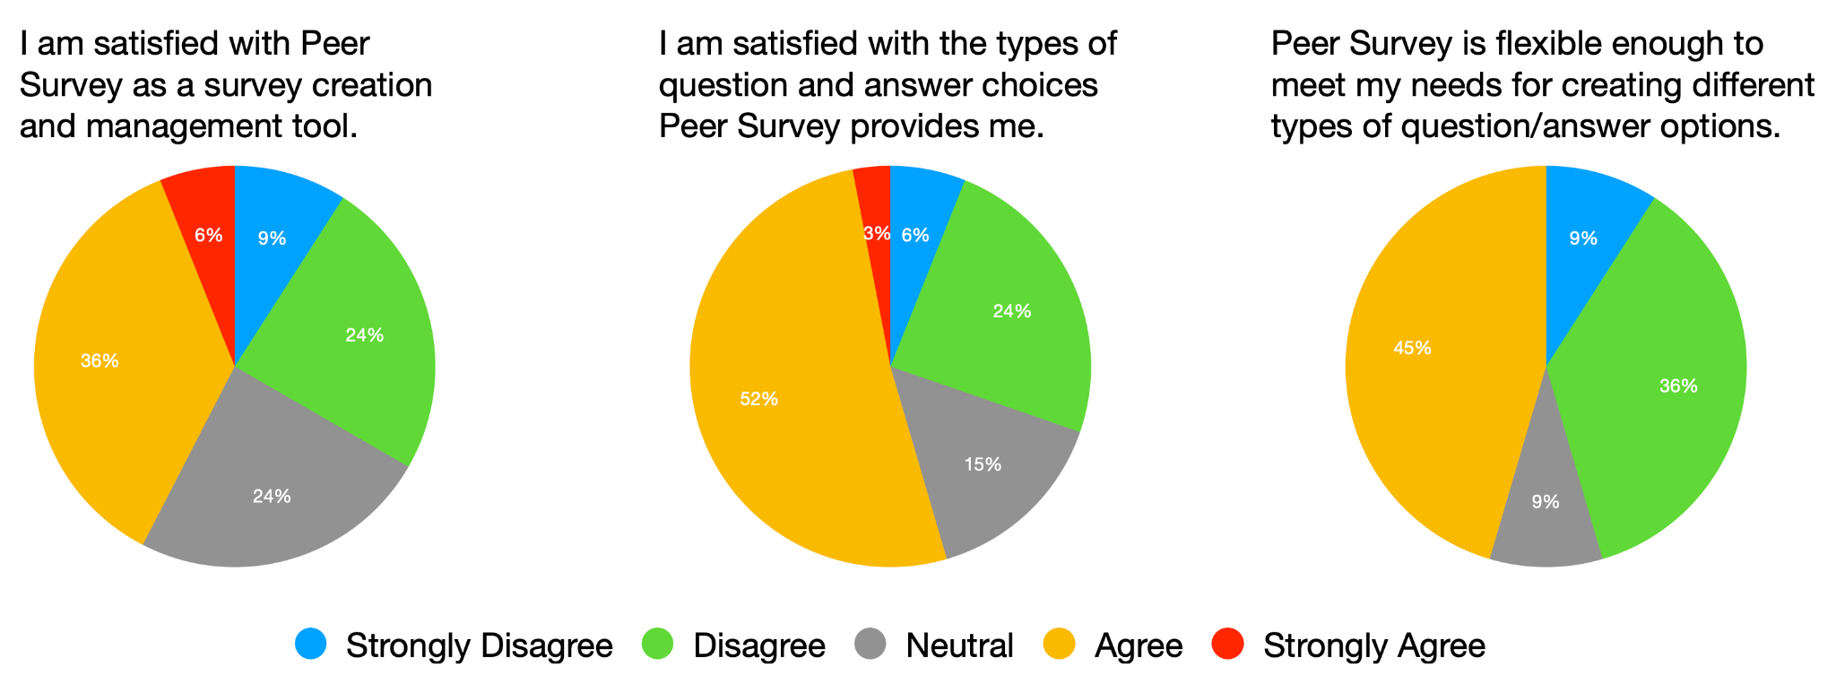

We also posed two questions related to collaboration in our needfinding survey, the results of which are below in Figure 2. An overwhelming 88% of respondents felt that enabling collaboration with others while creating surveys was an important feature to have in a survey platform, 33% felt so strongly. When asked about sharing the ability to edit surveys with collaborators, the response was nearly unanimous, with 97% of responses agreeing. Clearly our respondents agree that collaboration is a key feature to build in a survey platform, providing us another focus area during brainstorming.

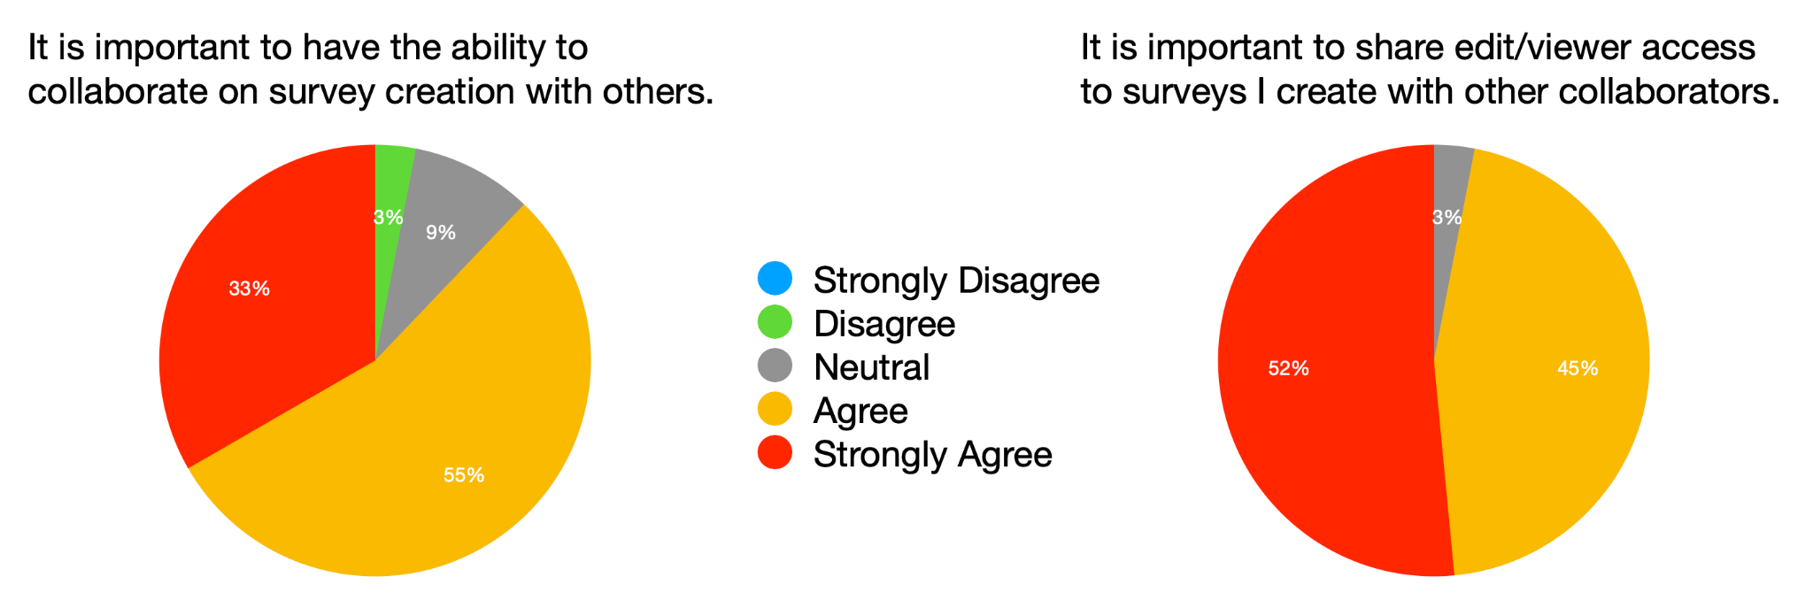

***Figure 2—***Collaboration-related questions from our needfinding survey.

Finally, we asked about the frequency and ease of including various kinds of media in surveys, including hyperlinks to external sites, images, and videos. As seen below in Figure 3, of those surveyed, 60% indicated they frequently found the need to include hyperlinks (24% very frequently), while 48% frequently needed to embed images and only 18% frequently needed to embed videos. 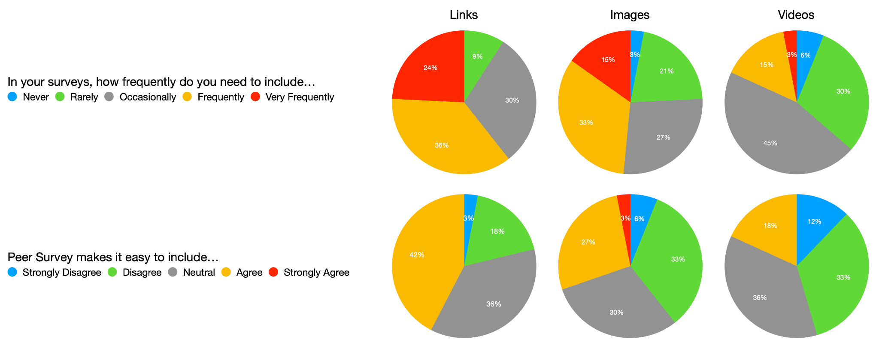

***Figure 3—***Questions related to embedding different types of media in surveys.

When asked about the ease of embedding hyperlinks, only 42% agreed that Peer Survey made this easy; 30% agreed that embedding images was easy, and only 18% felt embedding videos was easy. It appears that embedding videos directly into surveys is less necessary, but images and hyperlinks could benefit from attention, giving us yet another area to explore during brainstorming.

## 3.2 Heuristic Evaluation Results

Peer survey interface violates the **visibility of system status** heuristic principle since it doesn’t provide enough feedback in real time. For example, it doesn’t provide any indicators that notifies users about their progress while creating a survey (such as question 2 out of 10). Also, while it does display a “save your work” warning when the person is creating a question; it doesn’t provide a warning if a person leaves the page.

Another principle that we’re focusing on is **user control and freedom**. We noticed that Peer Survey doesn’t have undo or redo capabilities in case a user made a mistake and has to return to a previous version of the survey. While the interface does have a simple design that allows a user to transition from editing to publishing, it lacks the ability to actually preview the survey before releasing it to the public. Having a preview section might allow a person to catch mistakes before publishing.

The interface also violates the **consistency and standards** principle. On most survey platforms, the question types are usually called “Multiple Choice or Checkboxes”, “Radio buttons or Single Choice”, etc. However, on this platform the options are listed as “Choose Multiple”, “Choose Single”. Inconsistency with the verbiage may cause confusion and increase cognitive load for the user.

**Error Prevention** is another principle that we can improve within the interface. Currently, the interface doesn’t flag invalid inputs in real time or prevent form submission for mistakes such as incomplete questions. So if a person left a field empty, the mistake will be seen when the survey is published.

## 3.3 Participant observation results

Using Peer Survey, I went through the actual process of creating the survey to send out to students to evaluate the process as a user would. However while completing this process, it felt like it partially morphed into a cognitive task analysis, which actually helps with reducing confirmation bias.

Survey creation is straightforward with the “+Add New” button on the top right corner which brings up a pop-up form to fill out general details for the survey. Given this platform is meant for OMSCS students, it asks which course this survey pertains to which allows other students in the course to search for available surveys to complete for course credits (something that does not apply/make sense in other platforms). Additionally, it provides some options other platforms do not offer, such as how many responses to collect, an expiry date, and whether to publish the survey. However as a user creating a survey, it makes no sense to ask the user to set the publication of the status upon creation.

Once the user creates a new survey, instead of being redirected to the new survey page to add questions the pop-up form disappears and the “Your Surveys” page is refreshed to show the new survey added to the list with the following buttons: “edit, questions, share, responses” with the latter two being disabled and grayed out. A novice user may be confused with the options presented. For example, does clicking “edit” take you to the survey to add questions? But then why is there a “questions” button? I do recall the first time I used Peer Survey I wasn’t entirely sure what the difference was between the two options until I clicked around between the two.

When creating survey questions, it can get overwhelming to reorganize the questions by dragging and dropping when there are too many questions on the page. For instance, if you want to move a question all the way to the button, it is not easy to drag the question and scroll. It would be nice to have a simpler way to reorganize questions and be able to split them up into different pages.

It’s very convenient that Peer Survey offers default question types like frequency and agreement. However the rating scale isn’t entirely clear within the answer choices. Given these default types, a satisfaction and importance question type should be added.

There is an issue with the “Choose Multiple” question type. Oftentimes surveys will have an “Other” answer choice that provides a blank line for users to fill in a different answer. However, Peer Survey doesn’t provide this ability.

It also wasn’t entirely clear that I could use the “Choose one” question type in order to create a multiple choice question with custom answers. I’m not sure why but I was expecting to see a “Custom” option to represent this.

The process to publish a survey is hidden in the “edit” survey pop-up.

There is no way to share the survey with collaborators to edit the survey and view the results.

## 3.4 Needfinding Insights

There were a lot of insights gained from the needfinding activities with some of our suspicions confirmed and some not further validated by the survey results.

The heuristic evaluation and participant observation noted that Peer Survey does not follow standards for forms when dealing with “Other” answer choices or provide collaboration options. The heuristic evaluation also noted that it does not provide the ability to preview the survey as a participant before publishing while the participant observation identified the need for better question/answer customization. These findings were also supported by survey participants.

On the other hand, the heuristic evaluation and participant observation identified other areas where Peer Survey fails design principles or does not provide the best user-friendly interface that was not further supported by the survey data. However, we still believe that these areas are ripe for improvement.

We also identified a user need that was not initially suspected: conditional question routing. This was mentioned by several survey participants but was not uncovered during the other needfinding activities.

Even though several participants brought up the need for data analysis and visualization capabilities, this is outside of our scope of survey and question creation. As such, we will not move forward with addressing that particular user need in this project.

# 4 INITIAL BRAINSTORMING PLAN

To reduce social loafing and conformity/convergent thinking, our team will take a two-stage approach to brainstorming for our initial prototypes. First, each member of the team will execute a round of individual brainstorming, spending a period of time between 30 and 60 minutes coming up with ideas related to the core problem of survey and question creation. The goal is for each member to produce roughly 10 ideas across different categories involved with survey creation and record them for discussion during the second phase session.

While the general goal is to improve survey creation, there will be a focus on addressing the following needs:

* Improving question and response inputs/options
* Supporting question sections and conditional routing
* Including progress indicators and improving organizational abilities
* Adding survey versioning and previewing as participant
* Adding collaboration features

Our second phase of brainstorming will be a group session of all Team Forretress members, with a suggested length of 60-90 minutes. We will schedule a common time for all members to collaborate in real time, and share our ideas from the individual phase as well as continue to brainstorm additional ideas together. During the group brainstorming session our goal is to assemble a list of around 30 ideas, which we will refine into our three design alternatives.

Within the group session, there is a possibility of production blocking or power dynamics where louder voices or more experienced members are given more weight. To address this, we will ensure that each member has dedicated time to share their individual ideas in a round-robin fashion so that all members of the group share equitably in addition to encouraging everyone to participate in any discussion or idea generation activities.

However, with this two-stage approach to avoiding potential biases in the brainstorming phase, performance matching is still an issue. This can be addressed by timeboxing the brainstorming sessions to the proposed timeframes and scheduled meeting.

# 5 BRAINSTORMING RESULTS

The team met up for a group brainstorming session after most of the members completed an individual brainstorming session. To improve success, the team set aside the initial 10 minutes of the group session to allow time for all members to generate more ideas individually before sharing as a group. The two sessions netted us a combined list of 29 ideas, which we organized based on their function relating to survey creation.

After a couple days of reflecting on these ideas, we decided to focus on those centered around question/answer customization and conditional question routing. Each member will create a prototype with these particular features. In addition to this focus, each member may add additional features from the brainstorming list. Our brainstorming notes can be found in *Appendix 16.3 Brainstorming Results*.

## 5.1 Prototype 1 - Jonathan Disher

In our needfinding survey a common concern about Peer Survey was the lack of flexibility in question and response types, the ability to embed multimedia and hyperlinks into questions, and difficulties in populating multiple-choice options. I have selected some of the ideas from our Customizability category to implement to improve quality of life for users creating research surveys using Peer Survey.

My prototype will be a medium-fidelity wireframe that demonstrates these new design elements, including more flexibility for Likert-scale questions by allowing additional response ranges and custom label values. Multiple choice questions will have an improved method of creation: rather than a complicated pop-up modal that prompts the user to enter a delimited set of responses, the user will be prompted to add, delete, and edit the responses directly in the question. Multiple choice questions will also have the option of embedding multimedia, including hyperlinks, images, and videos, directly into the question responses. To help mitigate presentation order bias, multiple-choice questions will also have the option of presenting their responses in a random order to each respondent. Finally, the user will be able to create linked questions, useful in situations where an "Other" response warrants further expansion.

## 5.2 Prototype 2 - Dasaray Fyall

My medium fidelity prototype will be a redesign of the Peer Survey interface with additional features to enhance the user experience for survey creators. The redesign will include default template questions that will allow users to customize it (if needed), with the ability to add conditional flow capability for unique situations (such as allowing survey participants to provide a short answer if they select “Other”). In addition to that, I would add details that are usually common on other survey platforms such as indicators that will provide progress details and change the wording of the question type (for an example: use “Multiple Choice” instead of “Choose Multiple”) to prevent confusion.

## 5.3 Prototype 3 - Caitlyn Yu

For my medium-fidelity prototype, I’ll be using Balsamiq to create a wireframe of a survey platform diagramming the workflow of creating a survey, adding additional default question types with customizable options, and offering preview/sharing capabilities. Since 45% of survey respondents said that they liked Peer Survey because it ties into online courses, my prototype will be based off of Peer Survey but takes some inspiration from Google Forms for customizability.

# 6 INITIAL PROTOTYPING

More wireframe screenshots of our initial prototypes can be found in *Appendix 16.4 Initial Prototypes*.

## 6.1 Prototype 1

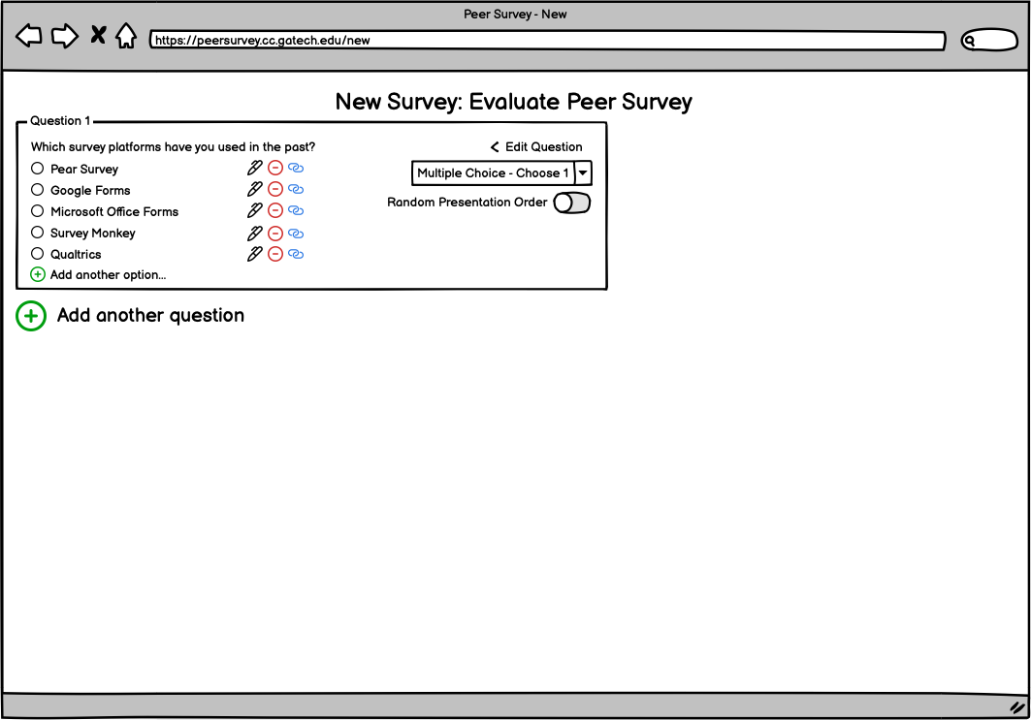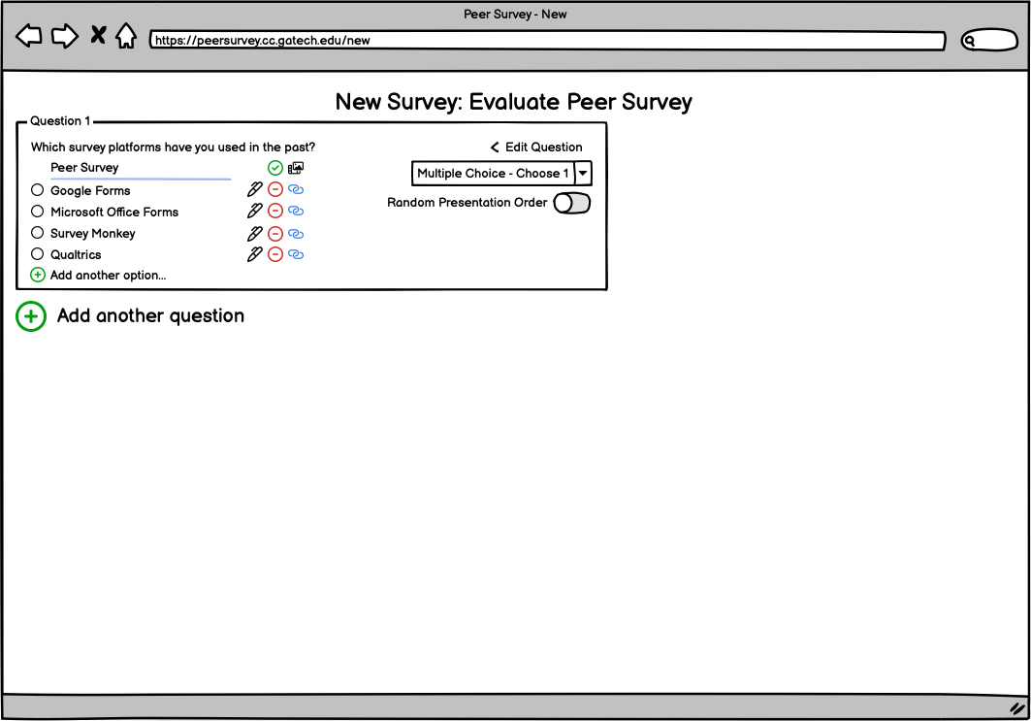

***Figure 4—***In-line editing of question responses during survey creation.

My prototype depicts the creation of the first few questions in a new survey. In Figure 4 above, the user is able to click the pen icon next to a response to correct a typo directly in the form. Simple iconography, such as the pen for edit and the linked chain for conditional question linking, provides signifiers to the user to make the interface more discoverable. Other controls, such as the on-off switch to enable random presentation order, are clearly labeled to prevent confusion.

Later in the creation process, after the user adds an Other option, the user can click the Link icon to create a set of conditionally linked questions that will only be displayed if Other is selected in Question 1, as seen in Figure 5 below. The interface creates the first linked question, which is indented from the rest of the questions to provide visual clues that it is separate from the main question flow; the “Add another linked question” button below is so named to reinforce this separation. The title box of the linked question contains the related selection, in this case “Other…”, which triggers the conditional questions. After selection of the proper type, the short answer box is displayed.

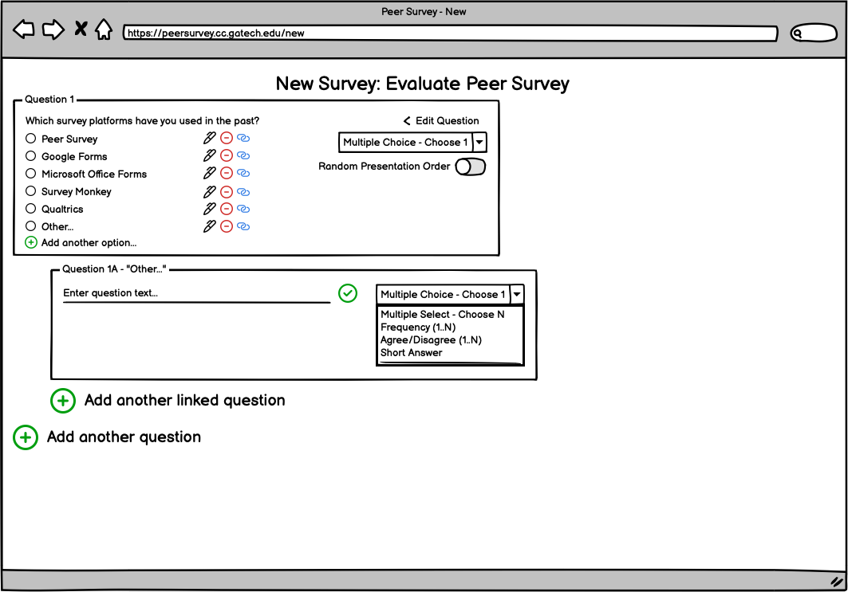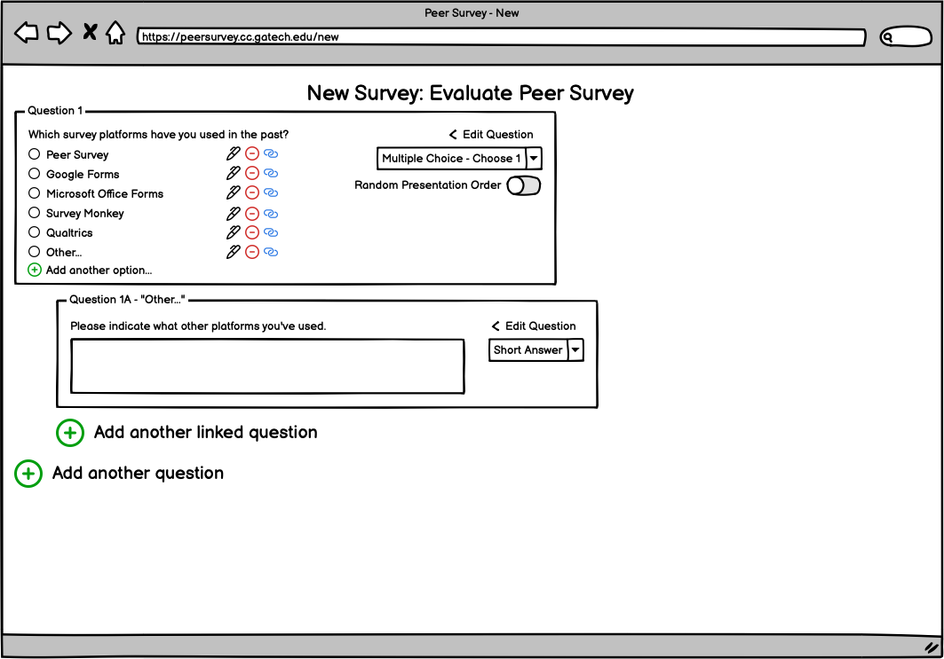

***Figure 5—***Creating a section of conditionally linked questions.

The goal for my design was to address concerns raised in our needfinding survey by allowing more direct, intuitive editing of questions, and providing additional flexibility and customization in the types of responses available to the survey creator. Additional functionality in the creation of conditional linked question sets would also bring feature parity with other platforms, while maintaining a simple, discoverable interface. A complete set of screenshots, as well as a link to the interactive version, can be found in *Appendix 16.4: Initial Prototypes.*

## 

## 6.2 Prototype 2

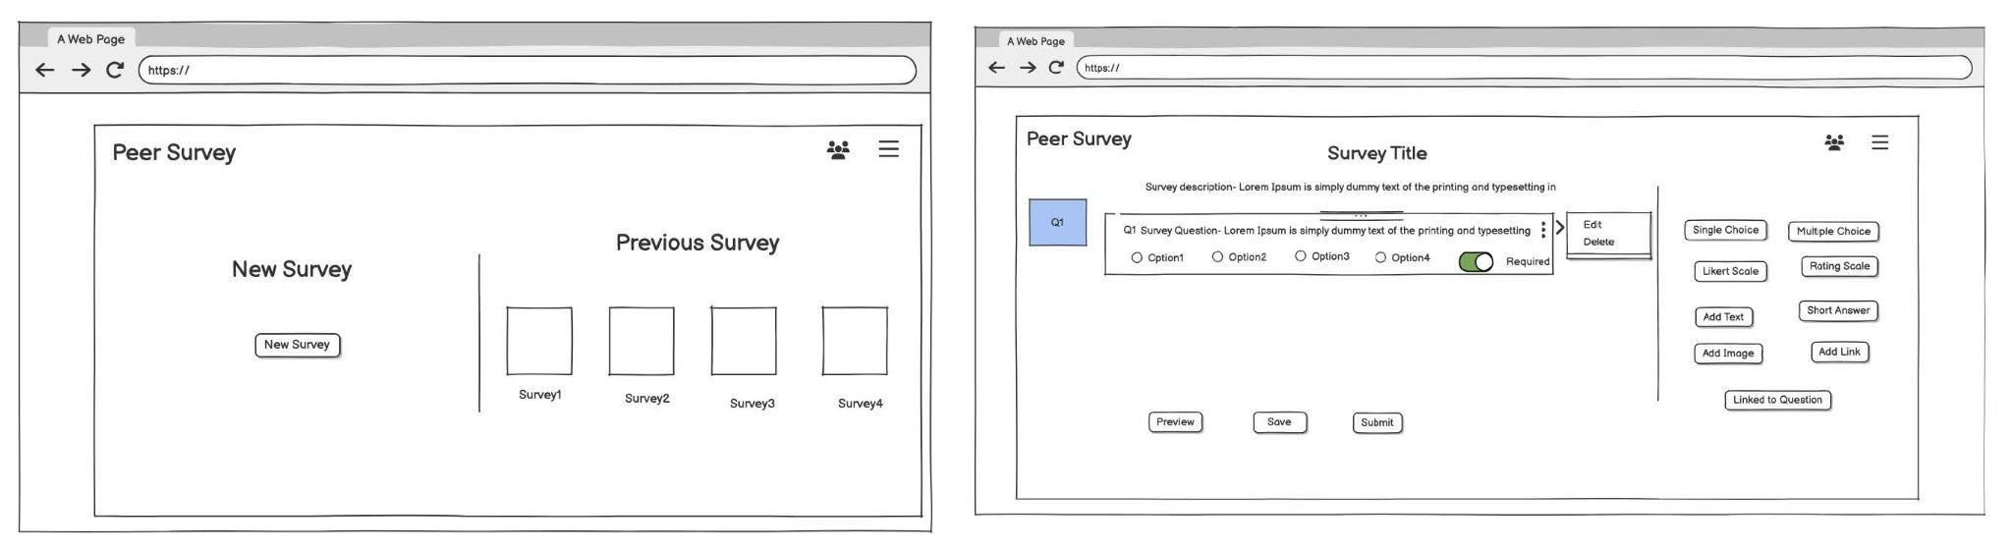

***Figure 6—***A view of the home page (left) and the second page that displays the default question and the drag & drop buttons (right).

The main page of the prototype consists of a minimalist design that allows users to simply create a survey by clicking the “new survey” button. On the right, there’s a section that allows users to click on icons in order to gain access to previous surveys. When a user clicks on “New Survey”, a new page opens with the default multiple choice question; however, a user can click the three dots to edit or delete the question.

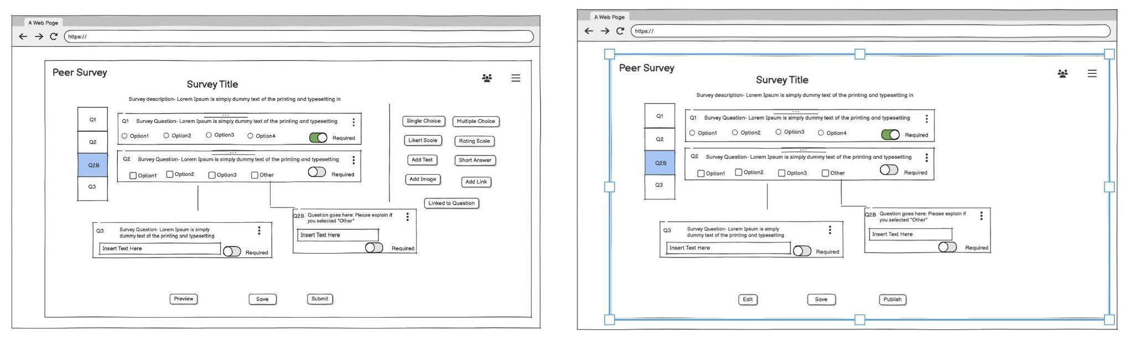

***Figure 7—***Displaying the “branching” feature (left) and the preview page (right).

If a user wants to add a different question, there are drag and drop buttons that display the question types. A “Link to Question” button is also included if a user wants to create a question with a conditional flow or in other words, it allows participants to move to other questions related to the answer. The linked question would be displayed as a “branch” of the main question. The preview page is available for creators to review the survey before publishing to the public. This page includes buttons which allows the user to select edit, save, or publish. Each page includes indicators that show the number of questions, with the current question highlighted for navigation and a required button that notifies users that a response is needed before submitting a survey. A larger view of the prototype can be found in *Appendix 16.4: Initial Prototypes.*

My approach to this design is to focus on the principles that were brought to our attention during our heuristic evaluation. For example, the drag-and-drop feature for adding or linking questions and the menu that provides options to delete or edit questions give users more flexibility to make customizations within a survey(user control and freedom). Also, the indicators were added to provide feedback to the users while creating a survey (visibility of system status). These additions reduce complexity and it helps streamline actions to simplify the survey creation process.

## 6.3 Prototype 3

The landing page was a redesign of Peer Survey to list both open surveys and the list of user’s surveys. In Figure 8, once a user clicks “New Survey”, they are taken straight to the new survey page. The second image in the figure displays the sharing function when the user clicks the “eye” icon.

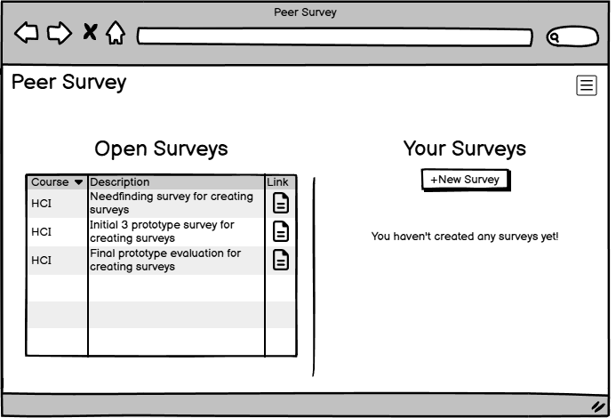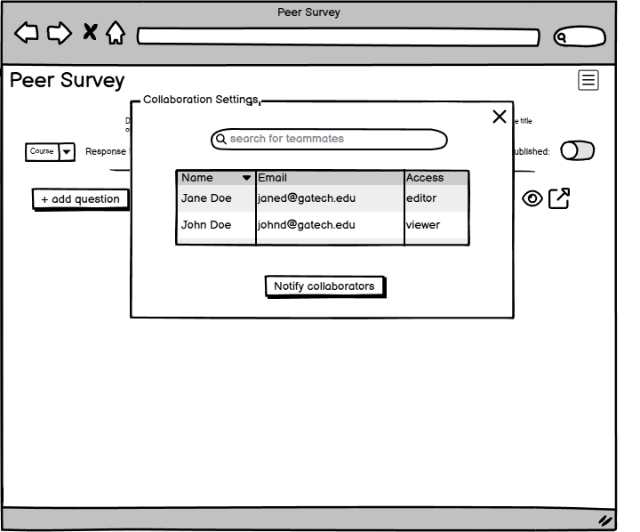

***Figure 8—***shows landing page and share settings menu for a survey

This design also improves navigation by moving the actions to add question, save, preview, share to the top of the survey so that users don’t need to scroll to the bottom as seen in Figure 9.

Most significantly, this design changes how questions and answers are created. Instead of creating a default short answer question type like Peer Survey does, “Add Question” gives the users a dropdown of question types to choose from. The “Multiple Choice” question type also provides several more defaults to choose from in addition to a “Custom MC” type. For multiple choice types, users can directly edit the questions/answers in the flow of the interface itself thus providing more consistency with what users expect due to experience with other similar interfaces.

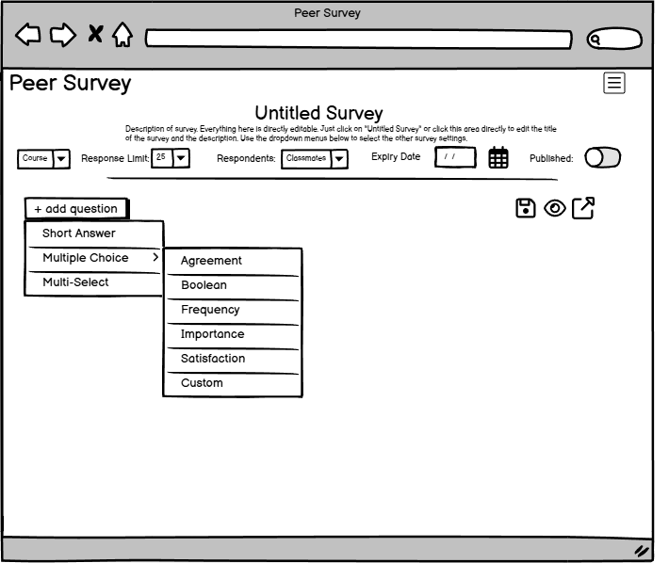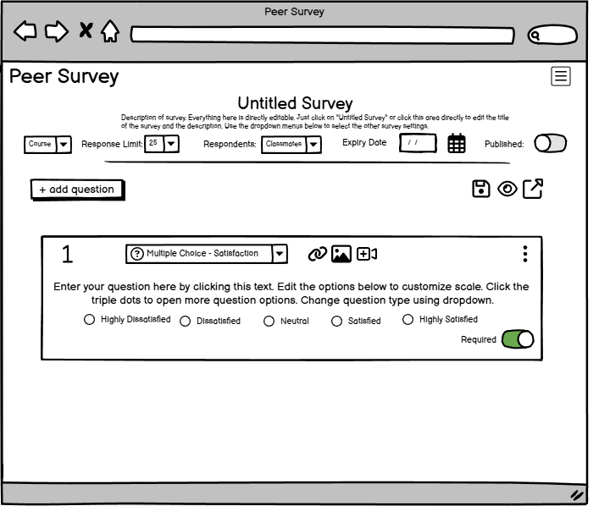

***Figure 9—***shows the new question workflow and its customizability as well as editability of the survey details itself.

Lastly, this design includes additional customization via the “vertical triple dots” which provides the ability to add more answer options, add a conditional question type based off of selected answer, change alignment of answer options, randomize order of answer options, or delete the question.

This design simplifies the interface and navigation, provides users with more freedom and control, and increases flexibility and efficiency by providing more defaults while maintaining a minimalist design.

See *Appendix 16.4: Initial Prototypes* section for additional images and interactive wireframe.

# 7 EVALUATION PLANNING

To evaluate the three prototypes, they will be compared against each other to determine the best way to redesign survey and question creation. Participants will be recruited via Ed Discussions for class participant credit with a goal of 20 responses. In the survey, participants will be asked to rate their understanding of the three designs to accomplish various subtasks when creating survey questions. This will allow us to evaluate which designs are more intuitive and easier to use for specific subtasks. Additionally, they will be asked short answer questions to gather qualitative data about each of the designs and what they like or dislike about them.

Using the data gathered, each subtask will show the percent of participants that agree with the statements about the interface. The results will then be compared across the subtasks as well as taken overall for each prototype.

See *Appendix 16.5 Evaluation Planning/Results* section for the complete survey questions and raw results.

# 8 EVALUATION RESULTS

## 8.1 Evaluation Survey Results

We received 24 responses to our prototype evaluation survey. Respondents were recruited via posts to the course Ed forum as well as the CS6750 Slack channel, and were incentivized with participation points in the course in addition to reciprocal survey responses for their own projects. The prototypes were generally well received, and the responses provide a clear direction for us to undertake our second iteration planning and creation of our final prototype. The quantitative review is separated into six sections grouped by function, plus one to examine respondents’ favorite prototype and another to discuss qualitative comments. A full list of the evaluations survey questions and raw results can be found in *Appendix 16.5 Evaluation Planning/Results*.

## 8.2 Evaluation Survey - Creation and Deletion

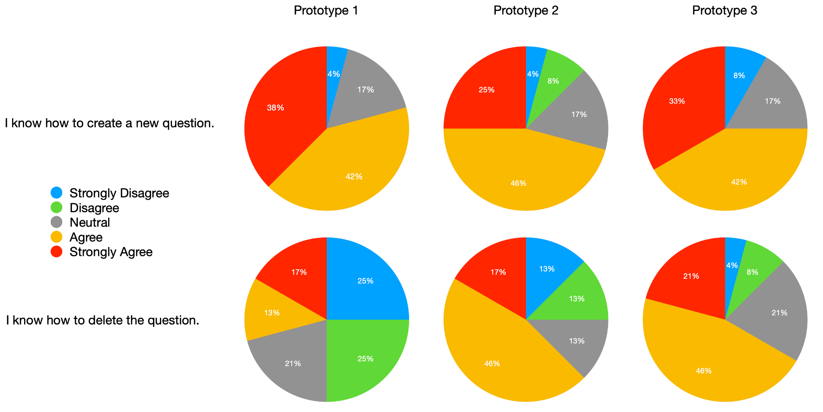

***Figure 10—***Response frequency related to creation and deletion.

Two questions on the survey dealt with the creation and deletion of survey questions. As seen in Figure 10 above, 80% of those polled agreed that they understood how to create a question in Prototype 1, whereas only 71% agreed for Prototype 2 and 75% with Prototype 3. However, Prototype 1 was missing clear indicators of question deletion, as only 30% of respondents felt they understood how to do so; 63% of respondents agreed for Prototype 2, and 67% agreed for Prototype 3. For our final design we should try to apply the design choices used for question creation in Prototypes 1 and 3, as well as the choices used to indicate question deletion in Prototypes 2 and 3.

## 8.3 Evaluation Survey - Edit and Rearrange

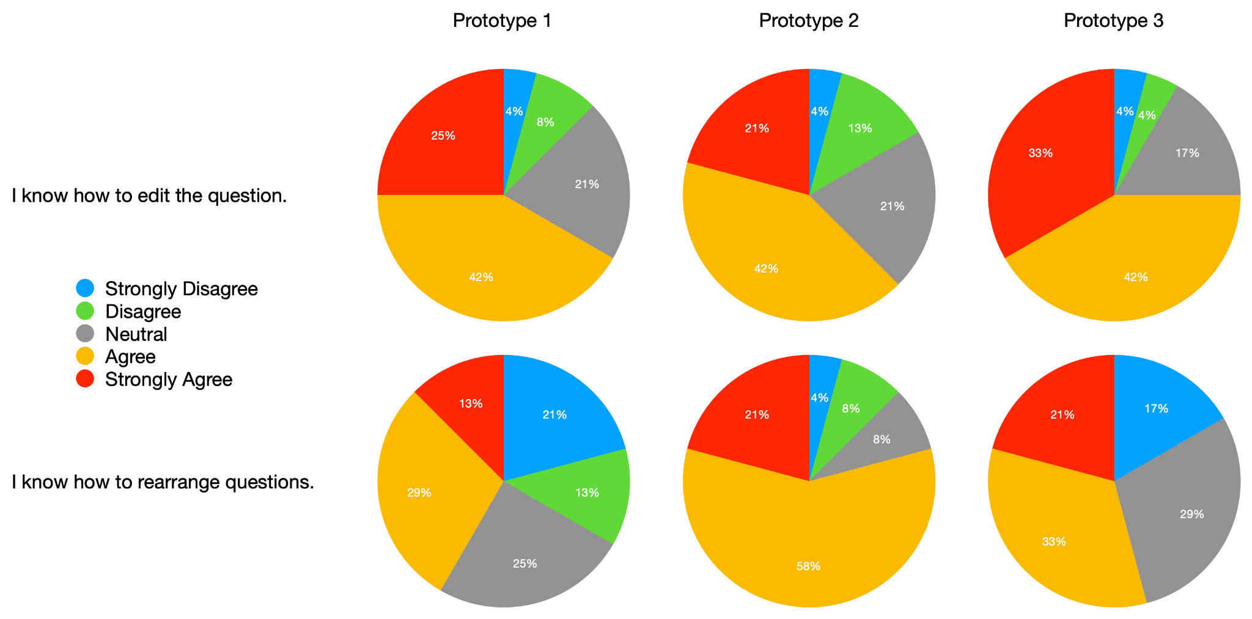

***Figure 11—***Response frequency related to editing and rearranging questions.

As seen above in Figure 11, when asked about editing questions, Prototype 3 produced the most positive response with 75% of respondents agreeing that they understood how to do so; Prototype 1 was the second clearest with 67% in agreement, with Prototype 2 close behind at 63%. Users responded most positively to Prototype 2 with regard to rearranging existing questions, with 79% of respondents agreeing that the process for doing so was clear. 54% of those polled agreed that they knew how to do so in Prototype 3, while only 42% agreed with Prototype 1. When planning our final design, we should closely examine the design choices made in Prototype 1 and 2 for question editing, while Prototype 2 likely has the best elements to implement for rearranging questions.

## 8.4 Evaluation Survey - Linked Questions

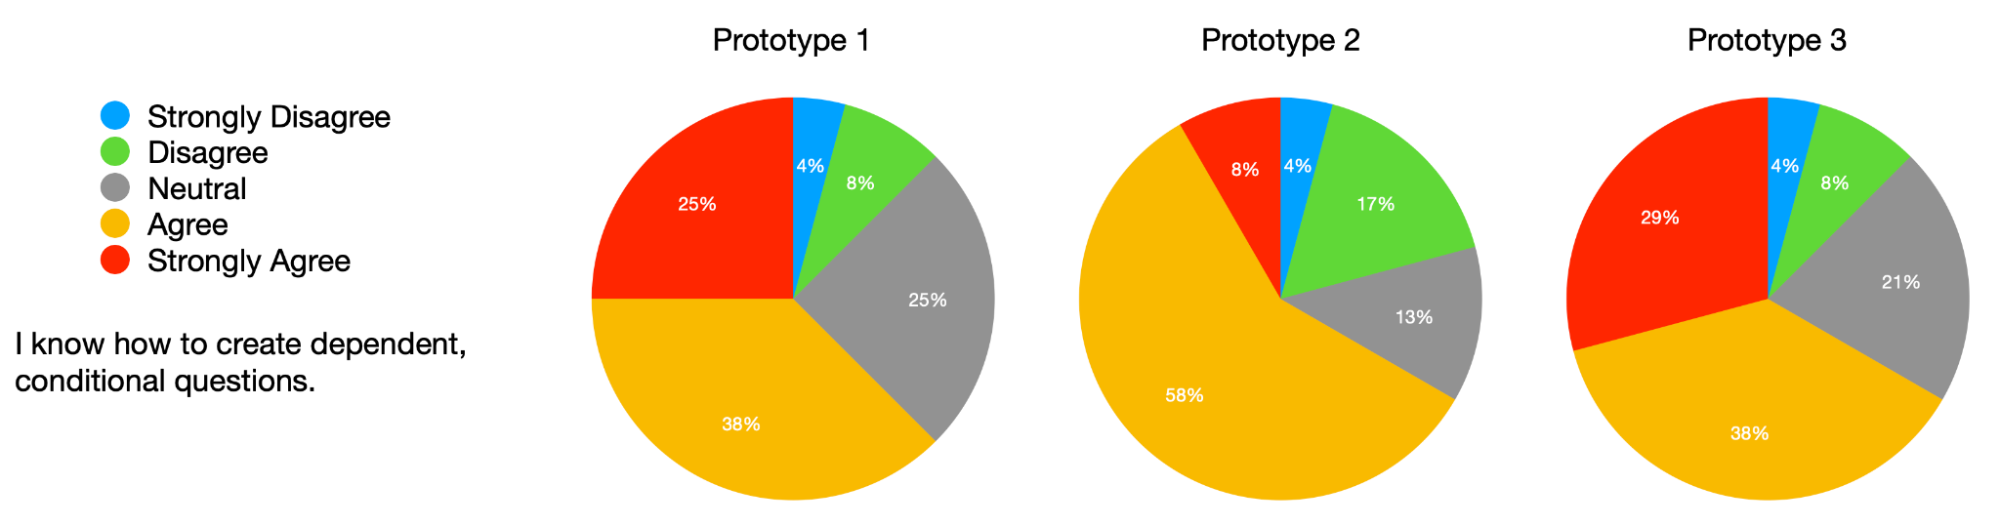

***Figure 12—***Response frequency related to linked questions.

One feature many users felt Peer Survey lacked was the ability to create groups of questions conditionally linked to specific responses in other questions. As seen above in Figure 12, all three prototypes provided clarity to roughly two-thirds of respondents, with Prototype 3 having 67% agreement, Prototype 2 with 66%, and Prototype 1 63%. Since agreement is so close, we can look at disagreement for differentiators; Prototype 1 and 3 had only 12% of respondents disagreeing, while Prototype 2 had 21%. Therefore we may want to prefer the design choices from Prototype 1 or 3 when preparing for our final design.

## 8.5 Evaluation Survey - Miscellaneous Customization

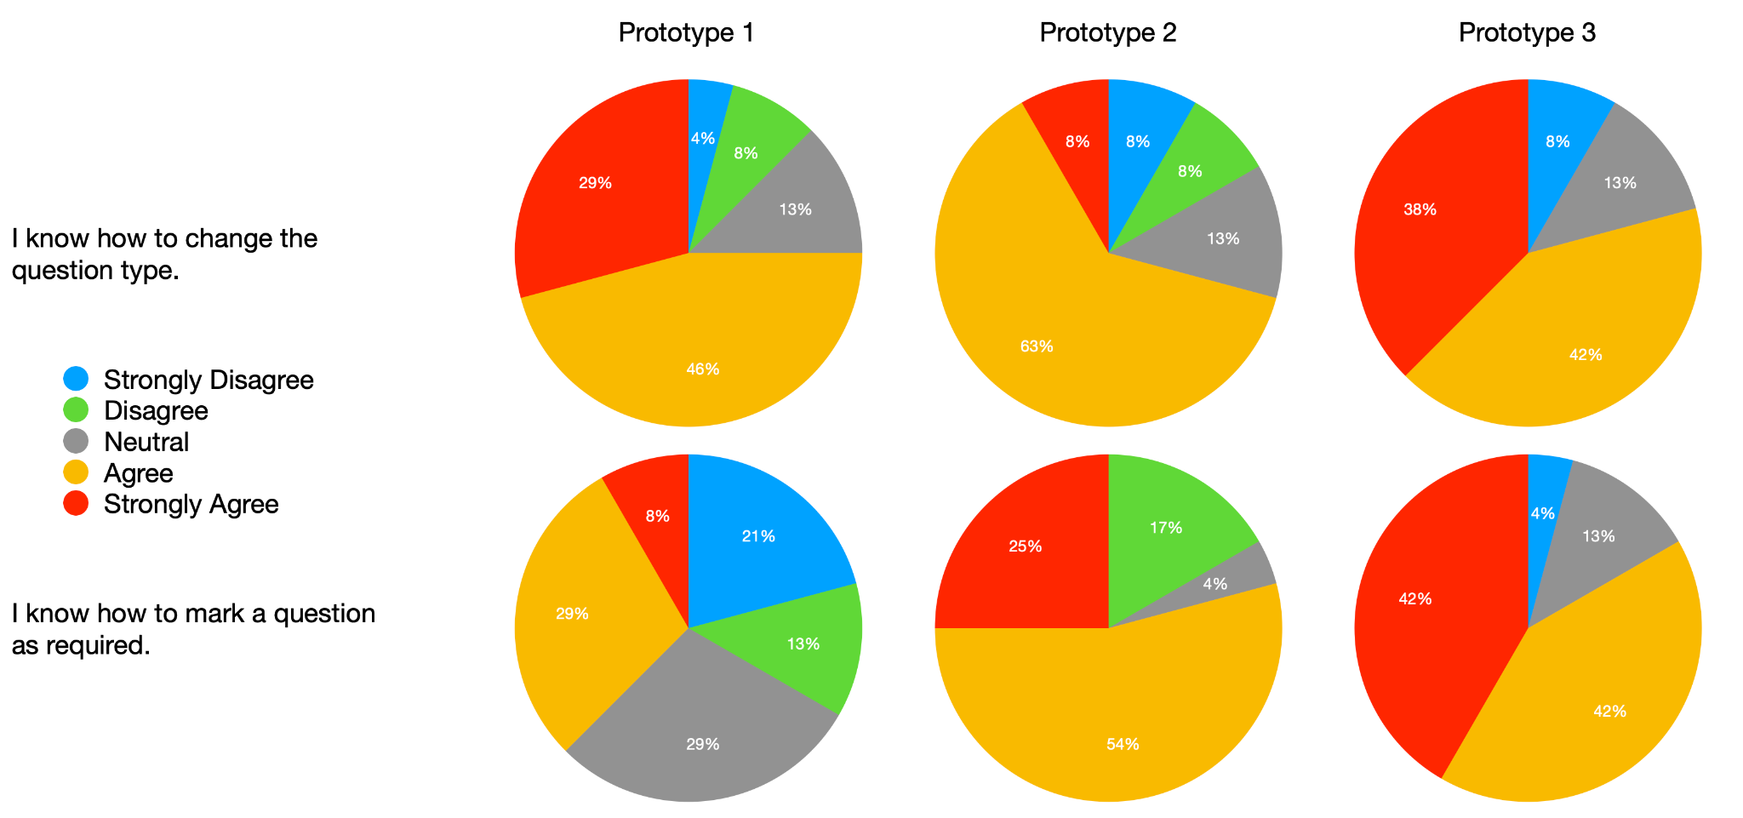

***Figure 13—***Response frequency related to customizing questions.

Prototype 3 appears to have the most clarity on changing the type of a question, with 80% of surveyed users agreeing that they understood how to do so. As seen in Figure 13, Prototype 1 and 2 were close behind with 75% and 71% agreement, respectively. However, Prototype 1 failed to clearly demonstrate how to mark questions as required with only 37% of users indicating they understood how to do so. Prototype 3 was also best for this feature, with 84% of users agreeing they understood how to do so, while 79% of users agreed that Prototype 2 was clear on the process. In planning our final design, Prototype 3 should be consulted for the creation of these features.

## 8.6 Evaluation Survey - Responses and Options

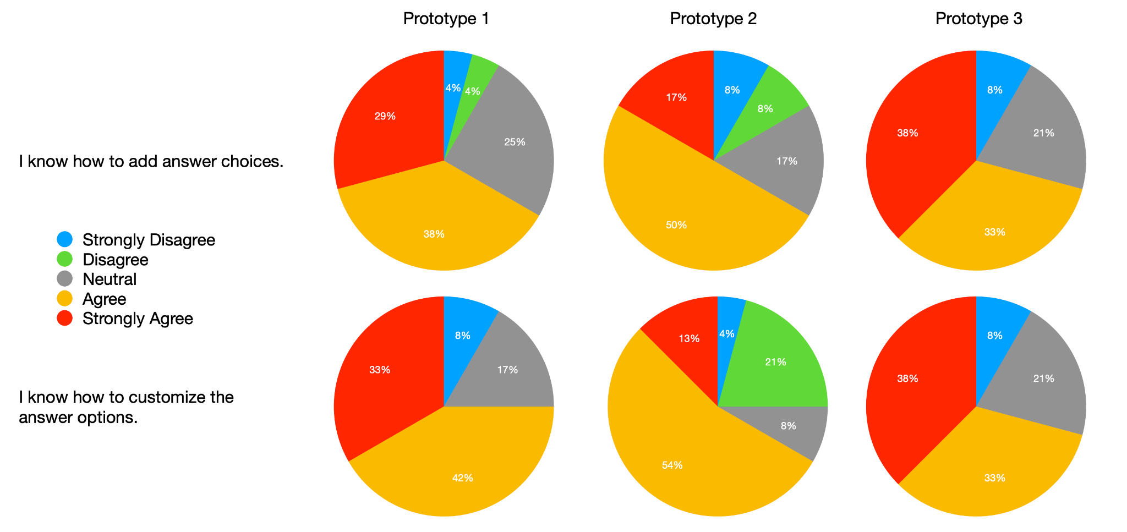

***Figure 14—***Response frequency related to answer options.

When asked about adding answer options to a question, Prototype 3 was the most clear to surveyed users, with 71% responding they agreed that they understood. Prototypes 1 and 2 both had 67% responding in agreement, though Prototype 1 had 29% strongly agreeing, with only 17% strongly agreeing for Prototype 2. As seen in Figure 14, 75% of users agreed that Prototype 1 was easy to understand with regards to customization of answer options, while 71% agreed for Prototype 3 and 67% for Prototype 2. Once again, all three prototypes provided similar levels of clarity for these features, so elements from all prototypes that contributed to ease of use in these features should be considered when planning for the final design.

## 8.7 Evaluation Survey - Advanced Options

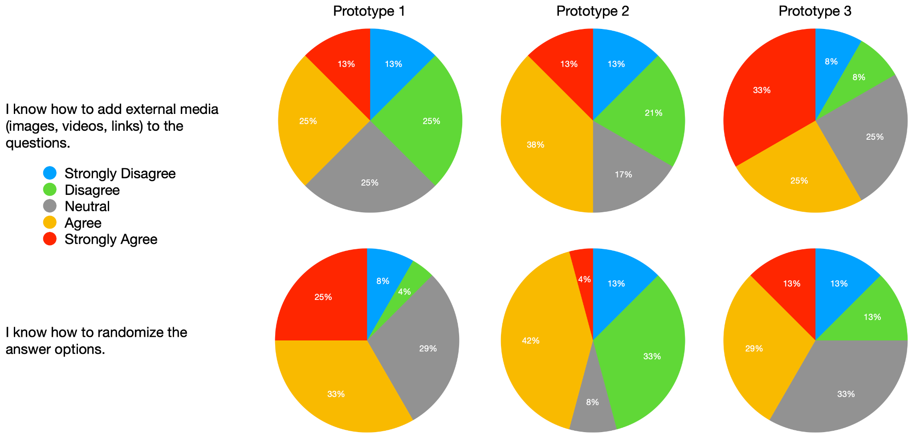

***Figure 15—***Response frequency related to more advanced options configuration.

When asked about more advanced question customization like embedding media into questions, as seen in Figure 15 above, Prototype 3 had clear advantages, with 58% of respondents agreeing that the path to success was clear. Prototype 2 was close behind at 51%, with Prototype 1 proving difficult to follow with only 38% of users surveyed agreeing that they understood the process. Users responded much more positively to randomizing the presentation of answer options, with 58% of users indicating they understood how to enable the feature on Prototype 1, while 48% understood how to do it on Prototype 2 and 42% on Prototype 3. We should consider Prototype 3 for pointers on embedding media into questions and Prototype 1 for presentation randomization in our final prototype design.

## 8.8 Evaluation Survey - Favorite Prototype

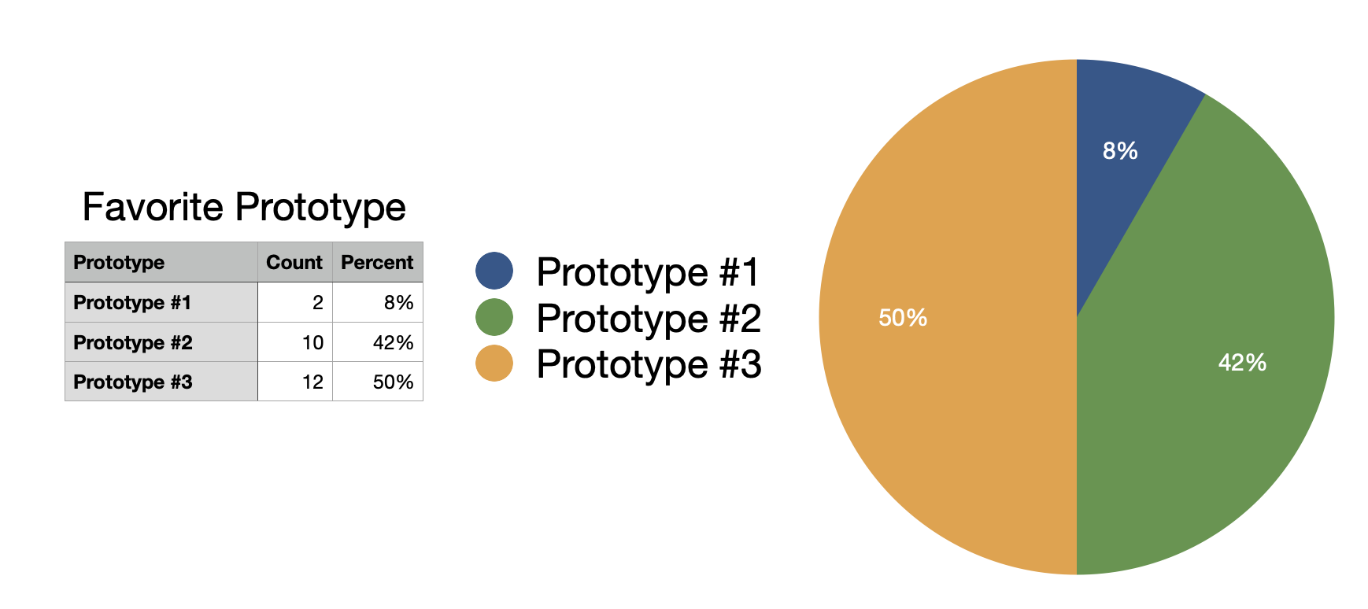

***Figure 16—***Indication of the respondents favorite prototype.

The final question is the simplest one: “Which prototype do you like best?” Prototype 2 and 3 were the favorite of 92% of users, with the latter holding a small 8% edge as seen above in Figure 16. While this question does not directly address ease of use or feature clarity, it does indicate that the overall presentation of those two prototypes were favored, so those considerations should be considered when blending features into our final design.

## 8.9 Evaluation Survey - Qualitative Responses

There were four qualitative questions in the survey. For each of the three prototypes, users were asked what they liked, and a final request for comments or suggestions. This final question had only one response related to the prototypes, suggesting a change to the Add Question button in Prototype 3; the rest were left blank or contained unrelated responses, and thus will be discarded. Responses to the other three qualitative questions were coded into seven categories, as shown below in Figure 17. The most frequent response was related to Ease of use, with 19 mentions, while responses related to the structure of the prototype or cleanliness made up 12 of the responses. 10 of the responses were related to other features or generally praised the features presented in the prototype, while another 10 were negative, usually indicating preference for a different prototype. 9 responses were unrelated, 7 related to question customization, and finally 5 mentioned question linking. A basic breakdown of the response counts would indicate that users found Prototype 2 to have the best structure and cleanest interface, while Prototype 1 was easiest to use and had the most customization.

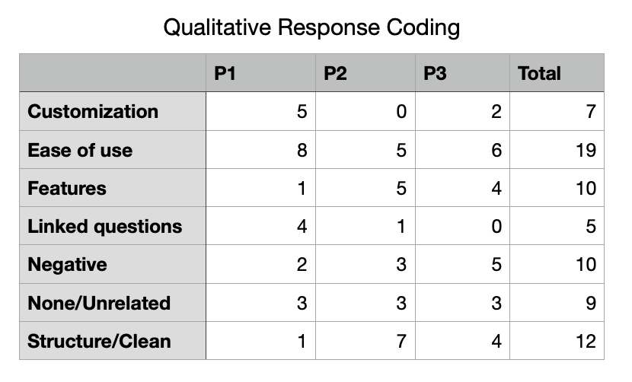

***Figure 17—***A chart of qualitative response coding.

However, there is little constructive feedback to be found in the responses to these qualitative questions. One response for Prototype 1 simply read “too many choices”, while another for Prototype 2 said “I don’t like the drag and drop”, and yet another for Prototype 3 simply says “Nothing in particular”; all three responses were coded Negative. It’s likely that the question should have been worded differently to explicitly request constructive feedback where possible. Unfortunately, there are few useful conclusions to glean from the qualitative responses to our survey; this is something we can improve upon in our final evaluation.

# 9 SECOND ITERATION PLANNING

While analyzing our evaluation results, we determined it was best to choose one prototype as a basis of the design look and feel, then implement changes based on feedback and select design elements from each prototype in each of the categories. Despite respondents favoring two of the prototypes significantly over the last, there was no clear winner, and each prototype had strengths in some areas and weaknesses in others. After reflection, we selected Prototype 1 as our starting point for our final iteration, and plan to merge it with individual elements and improvements from the remaining two prototypes.

Prototype 1 was the least favorite prototype, with only 2 of the 24 respondents favoring it. It tested well with users when asked about question creation, editing, linking, and response options; additionally, users favored the ability to randomize choice display order. We will utilize the indentation mechanic from linked questions, as well as direct click-editing of responses and the ability to resize range questions in the final design.

Prototype 2 was the second favorite prototype, with 10 of the 24 votes. The interface signifiers for question deletion and mechanics of drag-to-rearrange features that users felt were easy to understand, so we will pull those forward into the next iteration of our Peer Survey update. Additionally, users felt the toggle control to mark a question as Required was simple and clear, and we felt the left-side iconic representation of question order was a useful graphical indicator of survey length, so we will implement these in our next stage.

With half of the votes in the evaluation survey, Prototype 3 was the narrow favorite. This prototype was especially strong with its representation of conditionally linked questions, and the controls for embedding multimedia, while similar to prototype 1, were more prominent and easier to understand. We will also be implementing the choice of horizontal versus vertical orientation for question selection.

Our final design will be an amalgam of the best design choices from each of our three prototypes, with updates driven by feedback from each other as well as our survey respondents. Prior to implementing the final design changes, we will also review our survey results and internal team feedback to produce a final product that is easy to understand but flexible enough to suit student needs.

# 10 FINAL PROTOTYPE

A final more functional high-fidelity prototype combining aspects from all three design alternatives is provided below. The link to an interactive version is available here: <https://balsamiq.cloud/ssow1lj/p635ds1>. To walk through the different actions and workflows available, press down the “ALT” key and click the highlighted areas to navigate the prototype.

See *Appendix 16.6 Final prototype* section for more images.

The design decisions made in this final prototype was to simplify and expand the question creation process for Peer Survey by merging the best aspects of the three initial prototypes. Since GT students are encouraged to use this for their online courses, the following design is meant to improve the survey platform by implementing a minimalist design, simplifying question creation (specifically adding/editing answer options in place versus via a alert box), improving customizability (such as answer alignment, randomization, custom ranges, etc), adding the ability to link dependent questions, and including a left sidebar showing the number of questions and currently focused question.

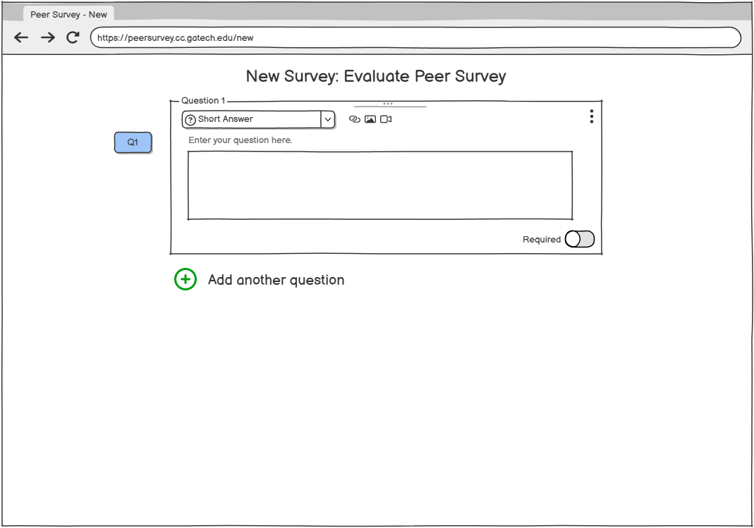

***Figure 18 –*** Survey page showing first question with default short answer question type

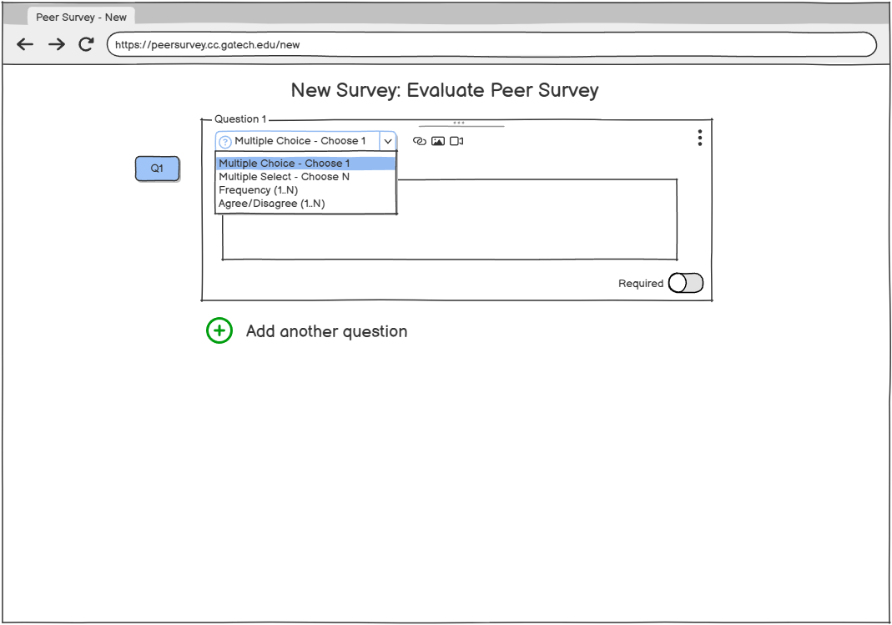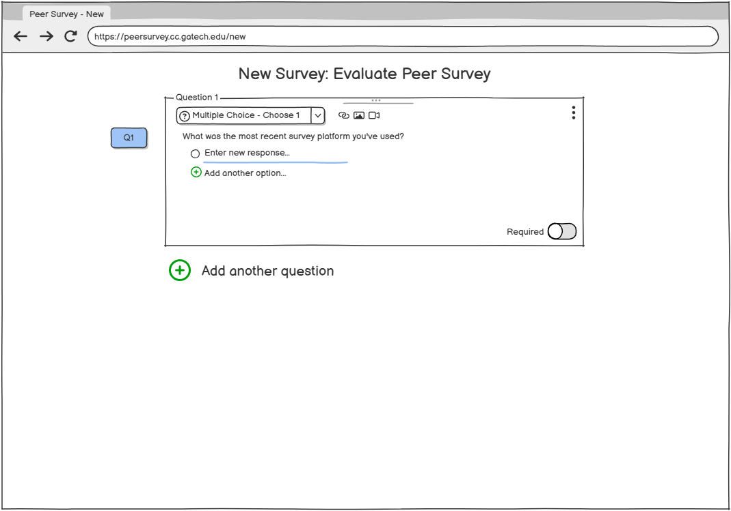

***Figure 19 –*** Changing question type and adding answer options

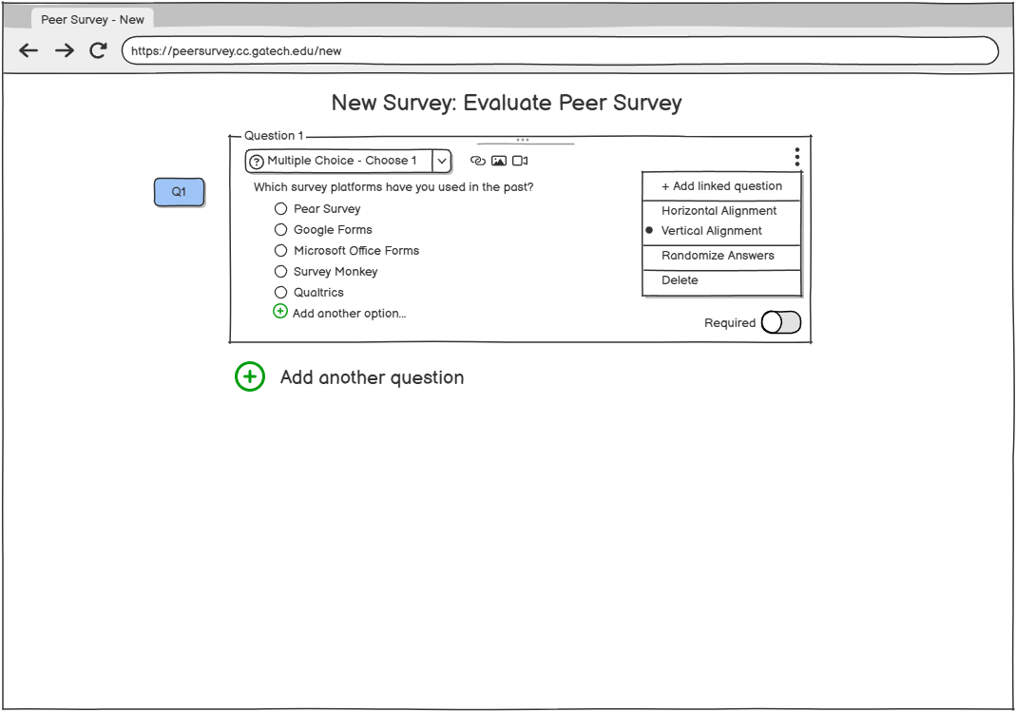

***Figure 20 –*** Filled out question showing open menu options

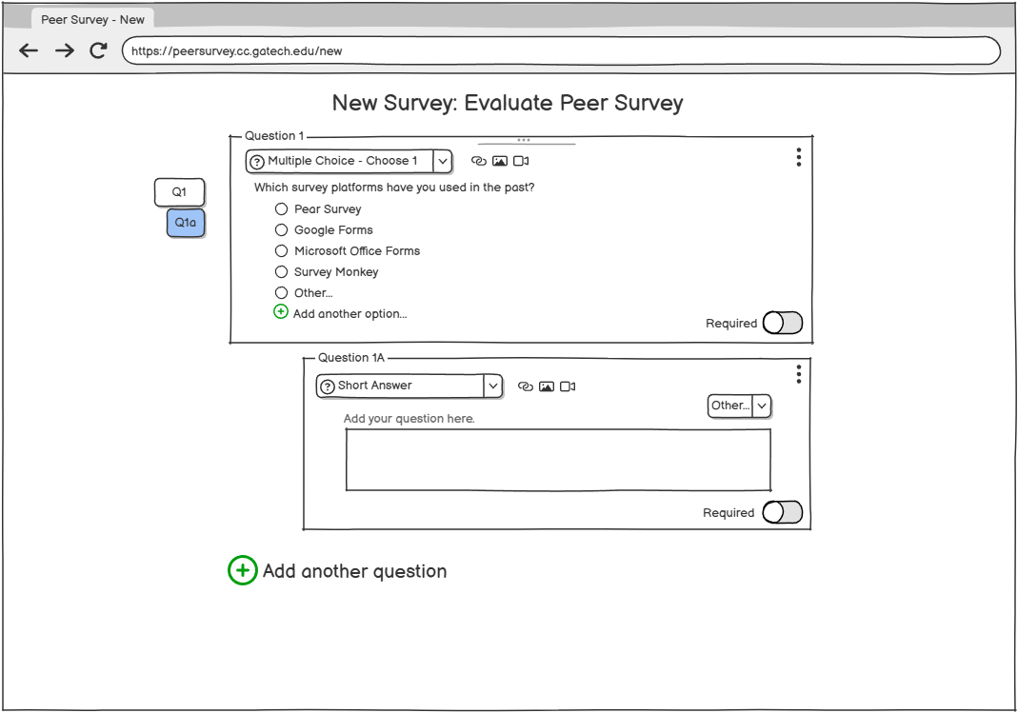

***Figure 21 –*** Clicking “+ Add linked question” from previous figure creates this sub-question with default short answer type.

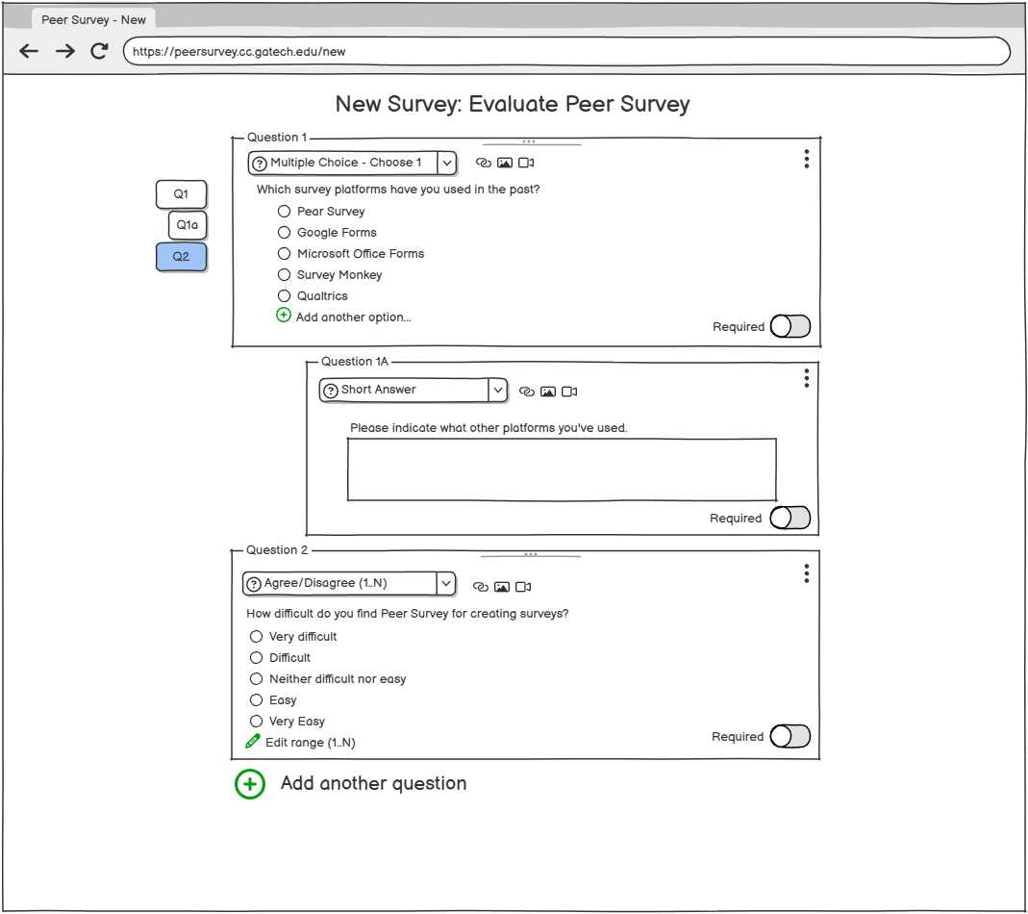

***Figure 22 –*** Second question showing the Agree/Disagree question type

# 

***Figure 23 –*** Clicking “Edit range (1..5)” and changing the number to 7 adds two more fields with custom labels

# 11 VIDEO PROTOTYPE

A short video walkthrough of the final prototype is available here:

<https://mediaspace.gatech.edu/media/Team+Forretress+Group+Project/1_a0stibm2>

# 12 FINAL EVALUATION PLANNING

The goal of this final evaluation is to test the usability of the final prototype while comparing it against the current Peer Survey interface. We will collect feedback from about 20 members of the Fall 2024 Human Computer Interaction class by providing a link of the survey through the Ed Stem discussion board. The survey consists of a short video that shows viewers how the prototype works, and questions that ask about their thoughts of the prototype. To get thorough and detailed feedback, we will ask participants quantitative questions such as “how easy is it to create a survey?”, “how likely they would use the prototype over Peer Survey?”, etc. and rating it on a scale from 1 to 5, where 1 means "very difficult" and 5 means "very easy". We will also ask open-ended, qualitative questions, allowing participants to share what they liked most about the prototype, what they found difficult to use, and what improvements they would suggest. The entire process will take about 10 minutes or less.

Once we’ve collected all the responses, we will be able to understand the overall user experience and the detailed challenges people faced between both interfaces. This will help us make additional improvements to the prototype before moving to the next step of the process which may consist of possibly developing the platform in the future (see *Appendix 16.7 Evaluation Planning/Results* for the raw data).

# 13 FINAL EVALUATION RESULTS

A total of 31 users responded to our final prototype evaluation that was posted on the class discussion form. In return, we provided feedback on participants’ surveys and the opportunity to obtain participation points. The responses that were gathered through this evaluation allowed us to determine if the prototype meets users needs when compared to the current interface. The quantitative questions focus on functionality and adaptation, while the qualitative questions provide insight on user preference, issues with usability, and improvement suggestions (see *Appendix 16.7 Evaluation Planning/Results* to view full final evaluation results).

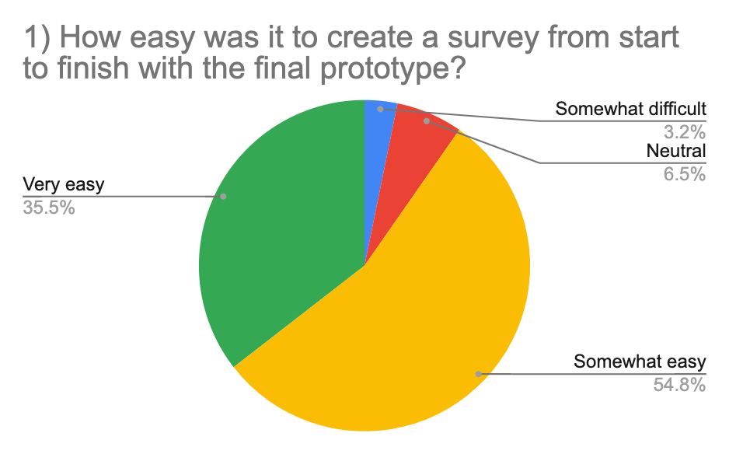

***Figure 24*** -User feedback on difficulty level of creating a survey with the final prototype

**Quantitative Results**

Functionality

Within the survey, three questions aim to focus on the useability and intuitivity of the prototype. According to ***Figure 24***, about 90% of users agreed that the prototype was easy to use throughout the entire process. In addition to that, about 93% of participants agreed that the enhanced features in the prototype were easier to use than the features that are provided on Peer Survey. Features such as adding logic to questions that were included in the final prototype made the user experience easier for 88% of the users.

Adaptation

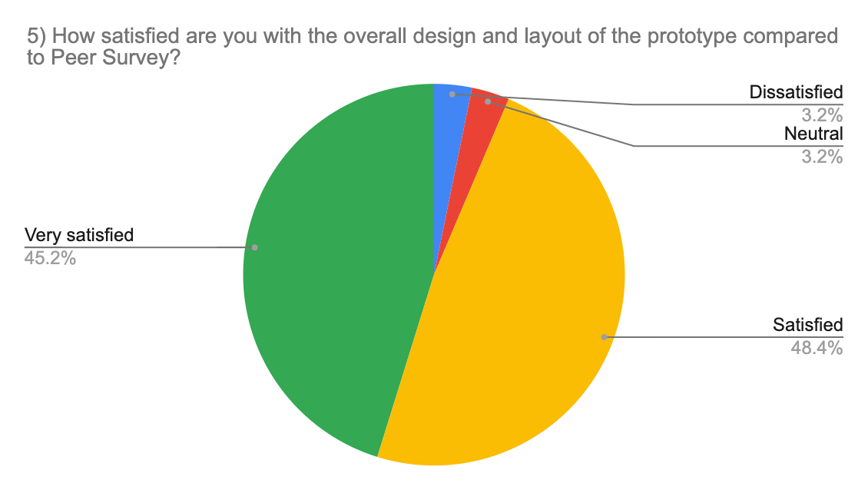

***Figure 25***-Users satisfaction with the final prototype compared to Peer Survey

On the other hand, three other questions provide insights on how well the prototype satisfied users’ needs and how likely a user will use the prototype over the current interface. Figure 25, shows 83% of participants were satisfied with what the prototype had to offer and about 81% think that the prototype meets their needs. The majority (90%) of users were impressed and would rather use the prototype than Peer Survey.

**Qualitative results**

The three qualitative questions allowed the team to obtain feedback from users about their preferences, any issues they may have experienced, and any suggestions for improvements. Users who actually left responses provided positive feedback. About 30% participants mentioned that the new features such as the conditional questions makes the process easier to navigate and about 23% users approve of the clean, simple design. On the other hand, about 6% users suggested a few improvements such as creating the ability to view data as a report or a chart, however this was outside the scope of our task for creating questions and surveys and would instead be a prime candidate for a followup design lifecycle to redesigning Peer Survey.

# 15 REFERENCES

N/A

# 16 APPENDIX

## 16.1 Appendix - Needfinding Survey Questions

1. I am satisfied with Peer Survey as a survey creation and management tool.
   1. Strongly Agree
   2. Agree
   3. Neutral
   4. Disagree
   5. Strongly Disagree
2. I am satisfied with the types of question and answer choices Peer Survey provides me.
   1. Strongly Agree
   2. Agree
   3. Neutral
   4. Disagree
   5. Strongly Disagree
3. Peer Survey is flexible enough to meet my needs for creating different types of survey question/answer options.
   1. Strongly Agree
   2. Agree
   3. Neutral
   4. Disagree
   5. Strongly Disagree
4. If you disagree with the above three statements, what is Peer Survey missing?
   1. Short Answer
5. It is important to have the ability to collaborate on survey creation with others.
   1. Strongly Agree
   2. Agree
   3. Neutral
   4. Disagree
   5. Strongly Disagree
6. It is important to share edit/viewer access to surveys I create with other collaborators.
   1. Strongly Agree
   2. Agree
   3. Neutral
   4. Disagree
   5. Strongly Disagree
7. How often do you need to include links in the surveys you create?
   1. Very Frequently
   2. Frequently
   3. Occasionally
   4. Rarely
   5. Never
8. Peer Survey makes it easy to include links in surveys.
   1. Strongly Agree
   2. Agree
   3. Neutral
   4. Disagree
   5. Strongly Disagree
9. How often do you need to include images in the surveys you create?
   1. Very Frequently
   2. Frequently
   3. Occasionally
   4. Rarely
   5. Never
10. Peer Survey makes it easy to include images in surveys.
    1. Strongly Agree
    2. Agree
    3. Neutral
    4. Disagree
    5. Strongly Disagree
11. How often do you need to include videos in the surveys you create?
    1. Very Frequently
    2. Frequently
    3. Occasionally
    4. Rarely
    5. Never
12. Peer Survey makes it easy to include videos in surveys.
    1. Strongly Agree
    2. Agree
    3. Neutral
    4. Disagree
    5. Strongly Disagree
13. What do you like about Peer Survey as a user surveying tool?
    1. Short Answer
14. What do you dislike about Peer Survey as a user surveying tool?
    1. Short Answer
15. What survey platforms have you used to create surveys?
    1. Short Answer
16. What specific features that you like do other survey platforms provide that Peer Survey lacks?
    1. Short Answer
17. What features would you like to see added to Peer Survey to make it a more useful or competitive option?
    1. Short Answer
18. Any other comments about Peer Survey not covered above?
    1. Short Answer

## 16.2 Appendix - Needfinding Survey Raw Results

See [Needfinding Survey and Results](https://docs.google.com/spreadsheets/d/1PvWdBFYN6E1aTMMdMhKZE5DlYIV5S750kbnyvz0KEcY/edit?usp=sharing) for raw results.

## 16.3 Appendix - Brainstorming Notes

Numbered questions

* Have the interface display the count of questions
  + Numbered questions that can be edited to rearrange questions
* Ability to split questions into different pages w/page indicators
  + Automatically split surveys by amount of questions, or complete options page to control this
* Ability to view in single page w/page split indicators
* Tag/label questions that belong together/same section
* Have the system estimate how long a survey would take based on question count and type

Error prevention

* Highlight fields in red if not completed, can’t move forward
* More feedback before leaving the page to save your work
* Allow undo & redo

Customizability

* Allow the user to define custom Likert scales (1-5, 1-7, 0-10)
* Custom labels for likert scale questions +
  + Customizable frequency questions
* Allow multi-select/multi-choice questions to present options in randomized order
* Allow images to be multi-select/multi-choice options
* More default questions like satisfaction and importance
  + Default question types/answers are editable
  + Multichoice questions edited directly in page
* “Other” input option, opens conditional question if selected
* Allow conditional questions
* “Add question” to add it to the beginning/end of survey
* Ability to upload media into survey instead of providing published links
* Create AI feature that provides suggestions based on theme or topic of other questions

Consistency

* Survey details directly in survey edit page
* Change the name of question type like instead of “choose multiple” use multiple choice
* Dynamic text box for questions/answers

Collaboration

* Preview, share, publish survey directly in edit page
* Preview mode for surveys
* Ability to flag questions for review by collaborators

## 16.4 Appendix - Initial Prototypes

Prototype 1: <https://balsamiq.cloud/ssow1lj/p635ds1> (interactive version)

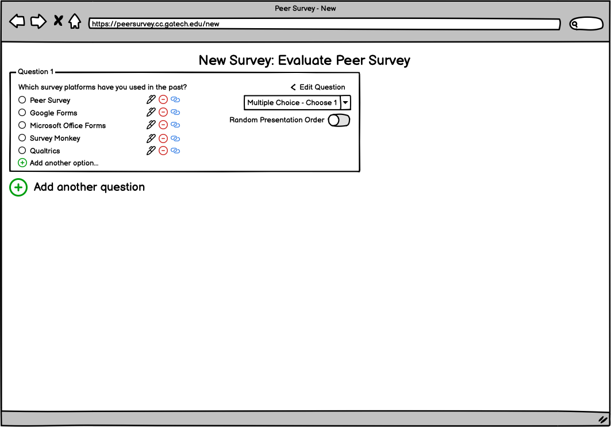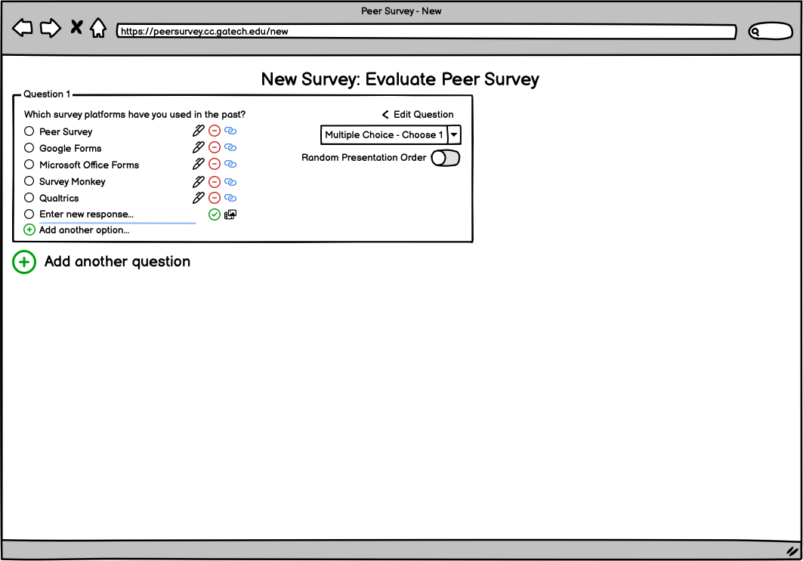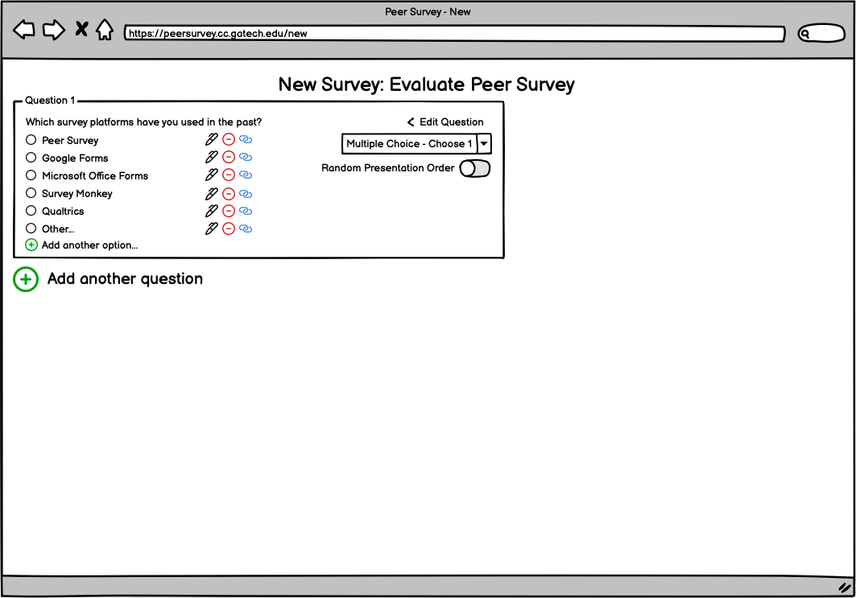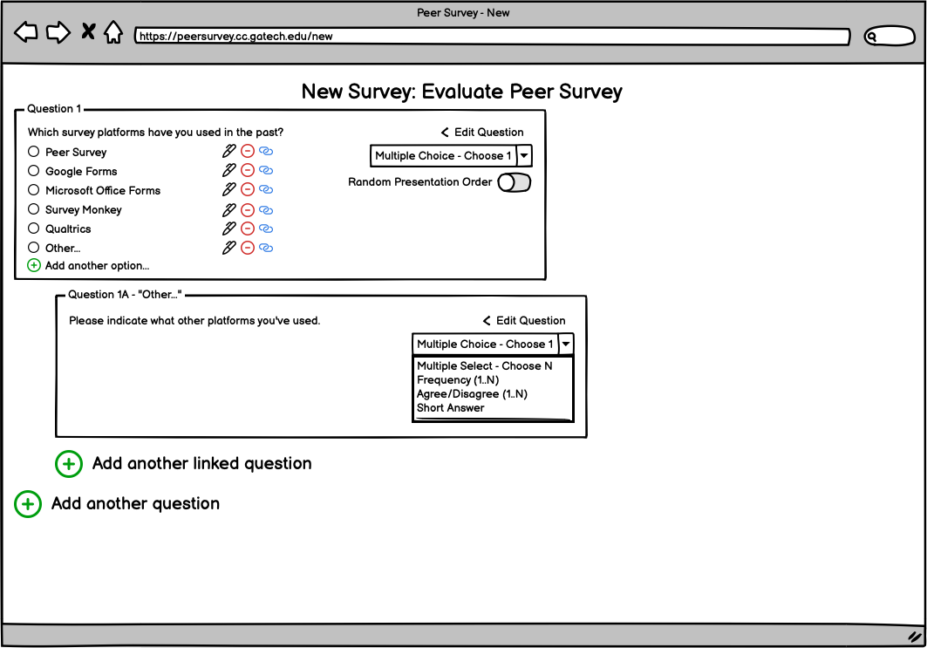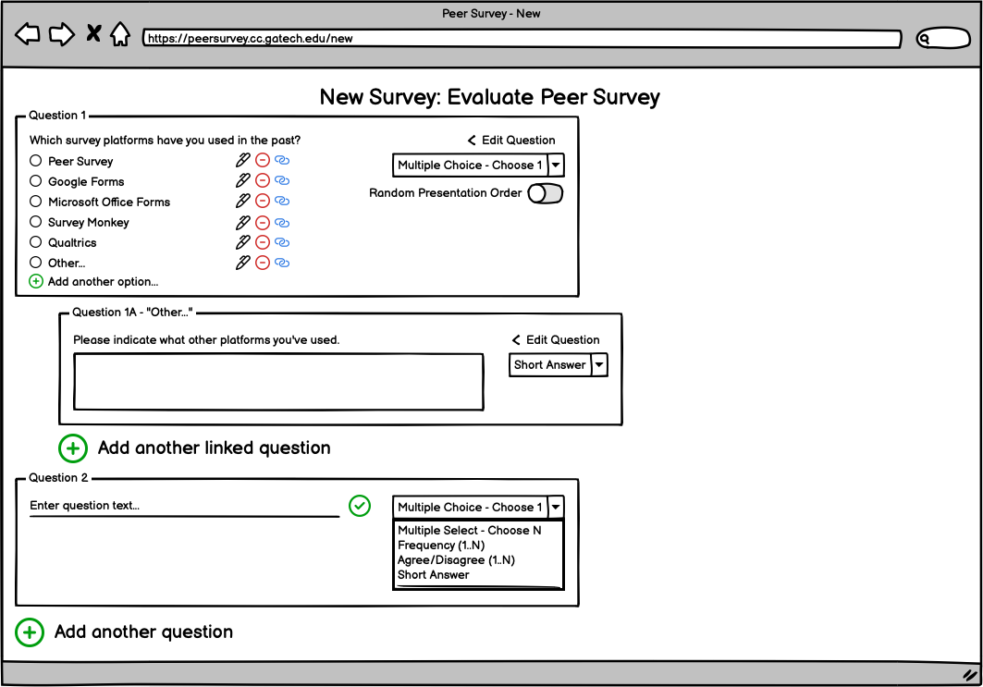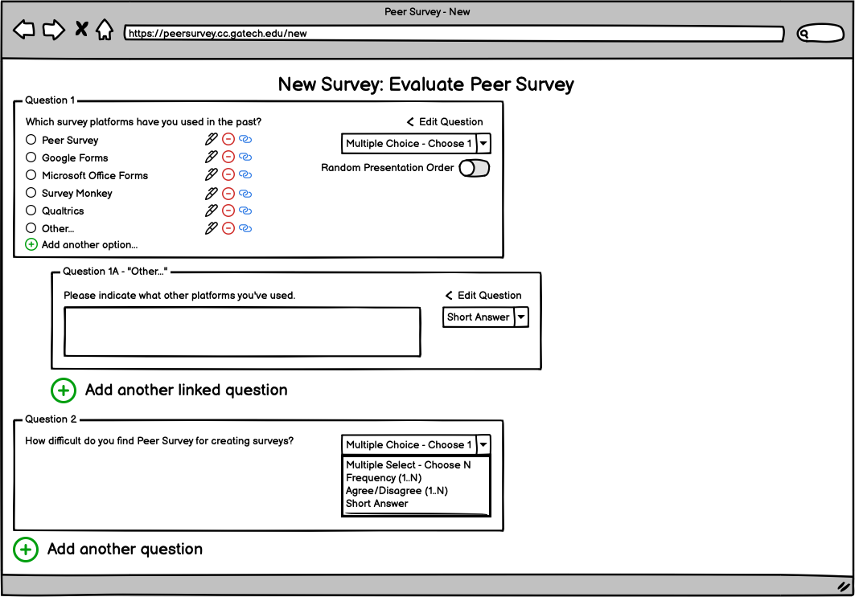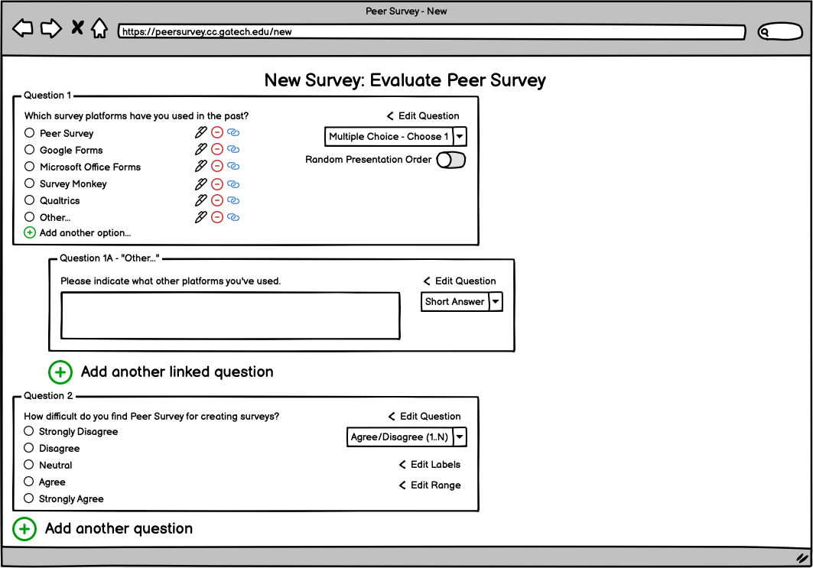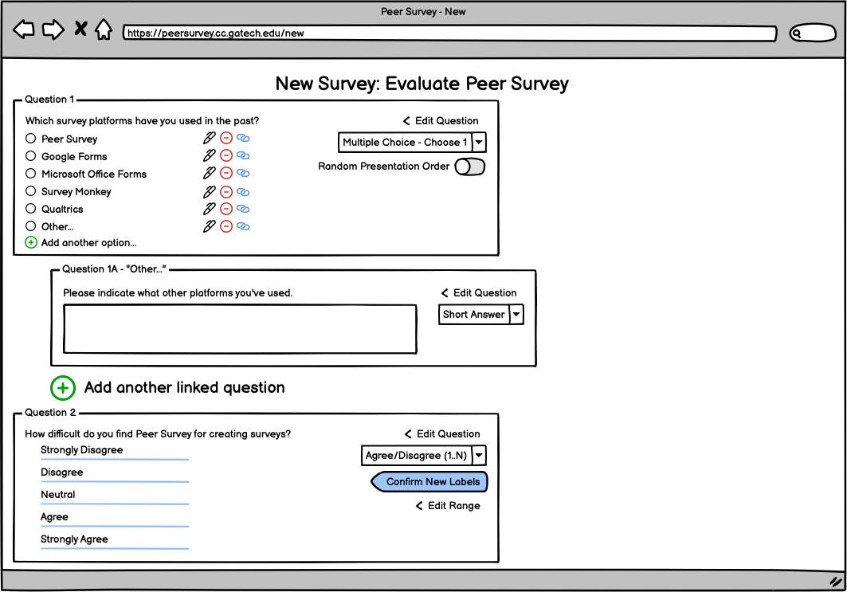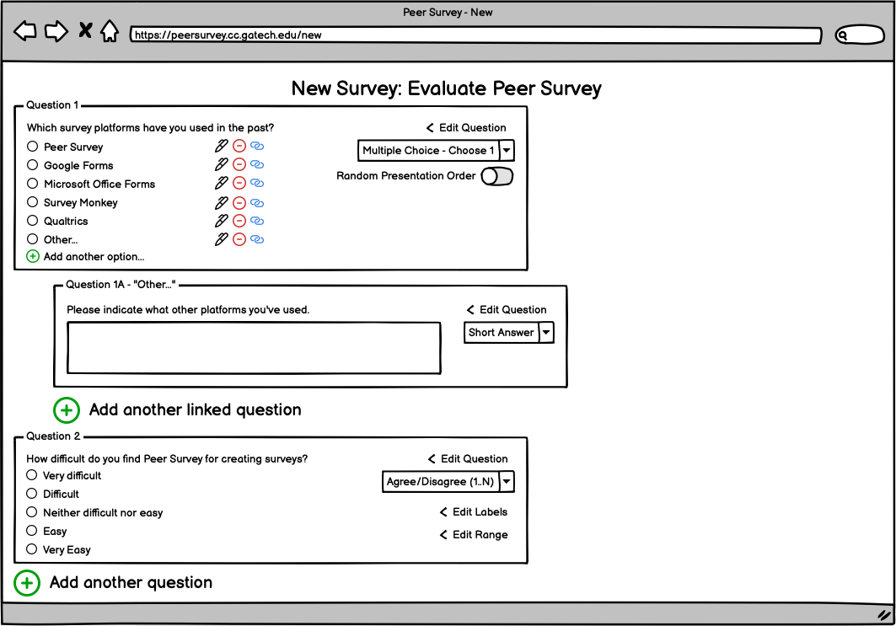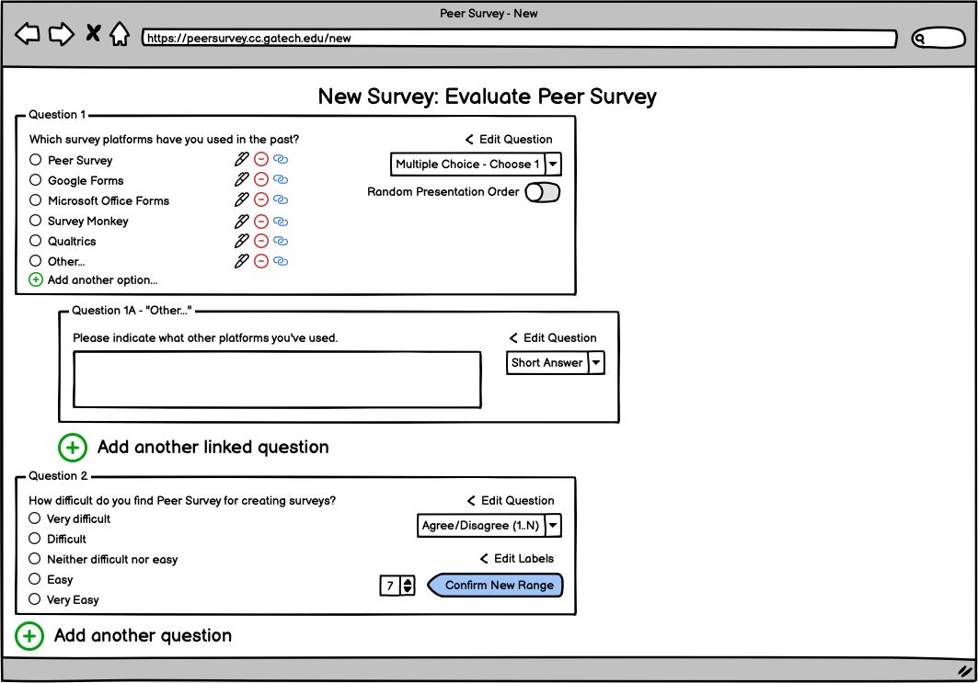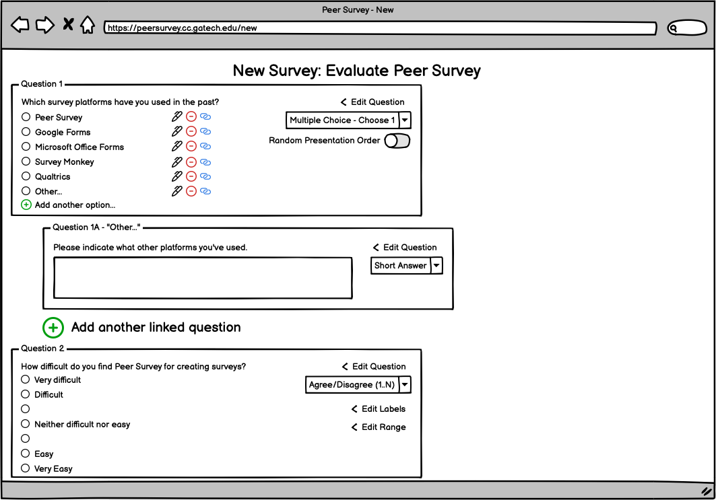

*Additional wireframe screens for Prototype 1*

Prototype 2: <https://balsamiq.cloud/s2klily/p4n8b2d>

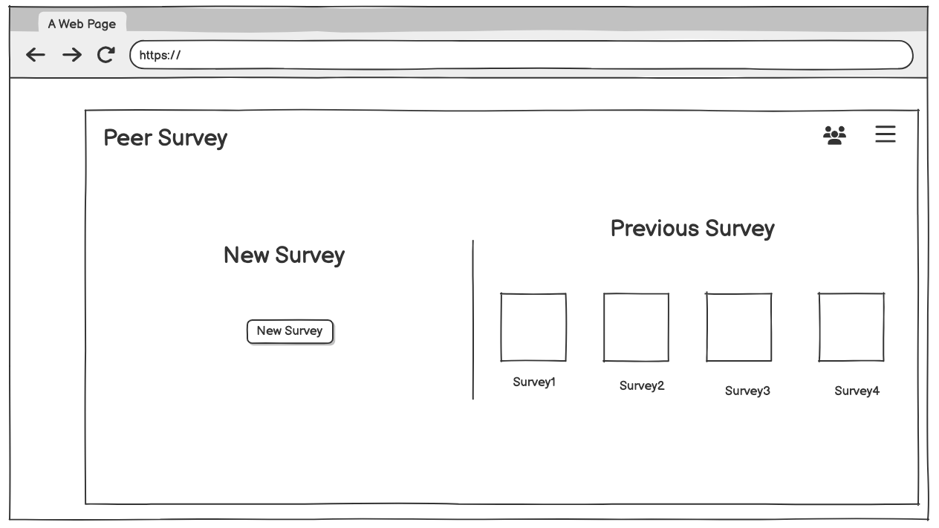

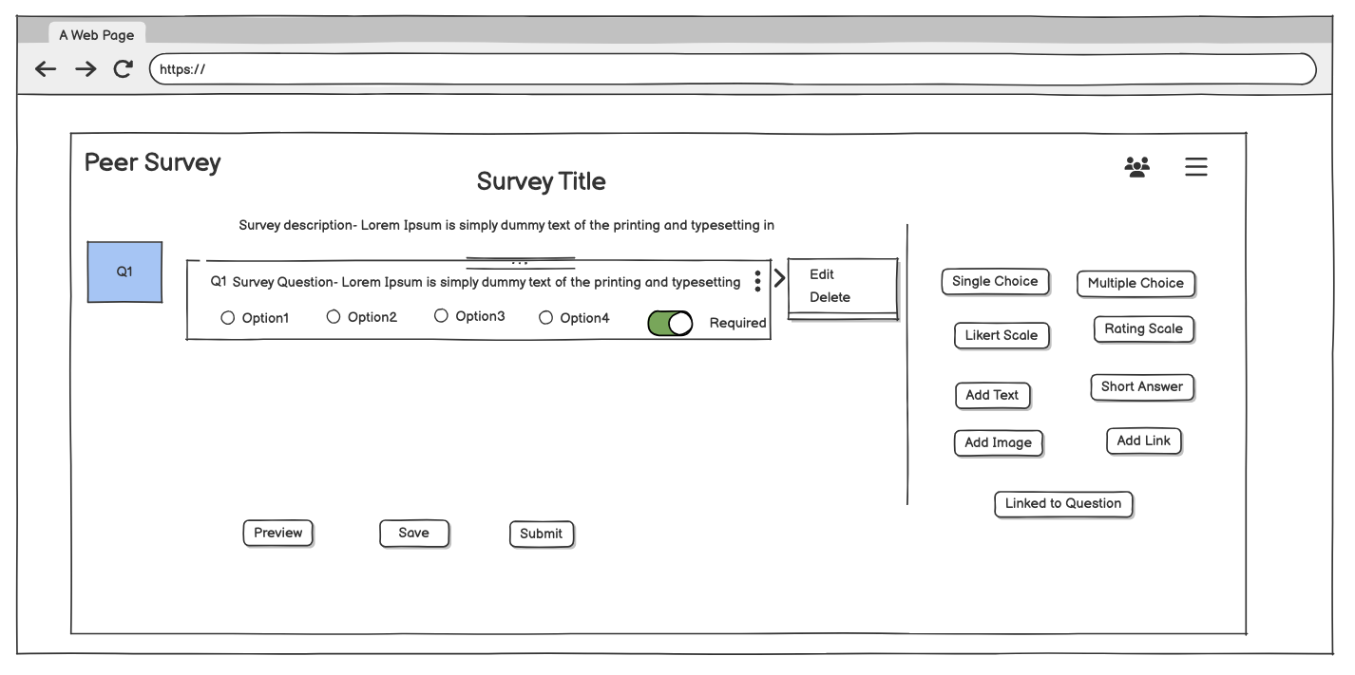

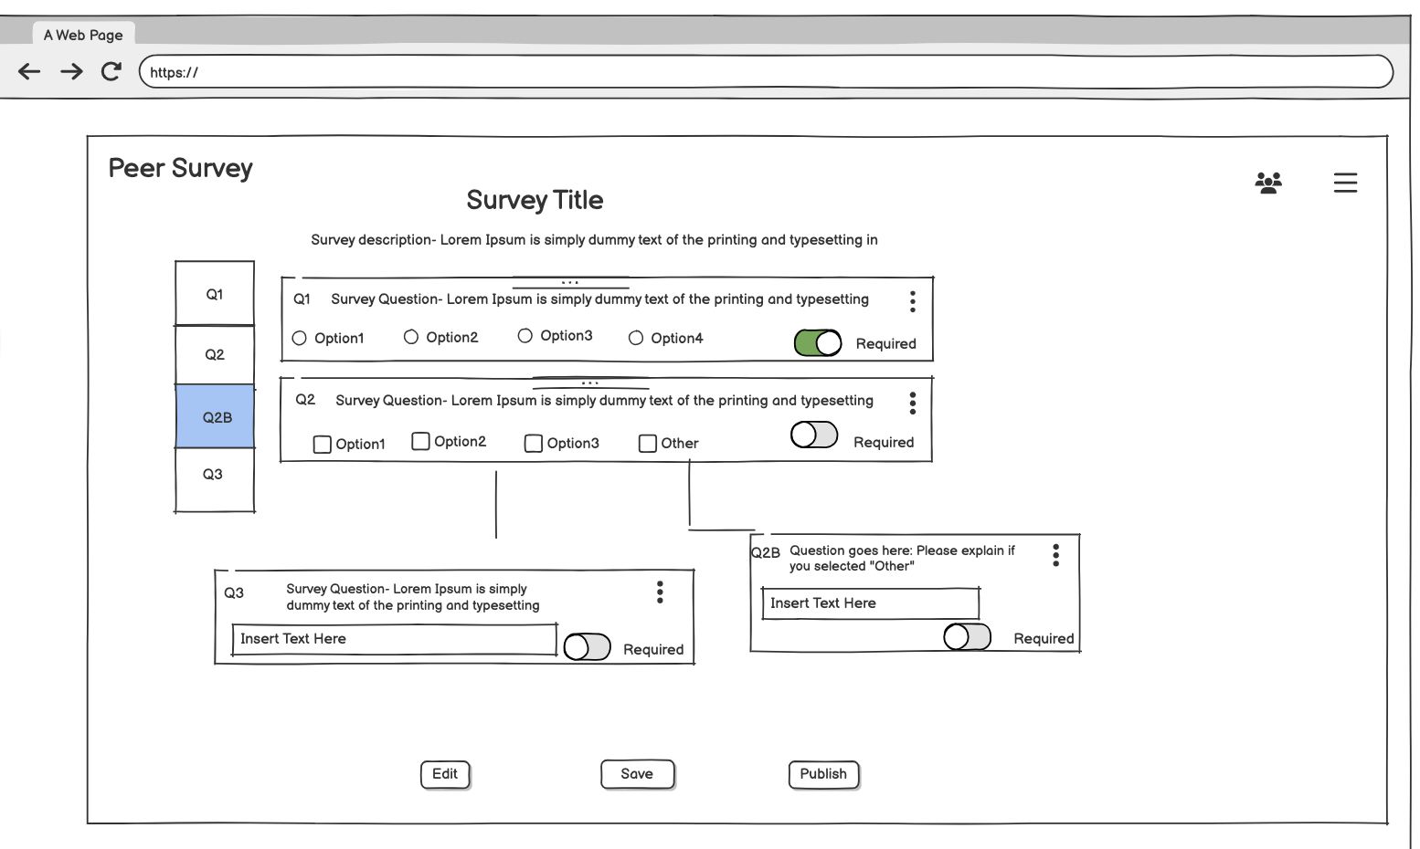

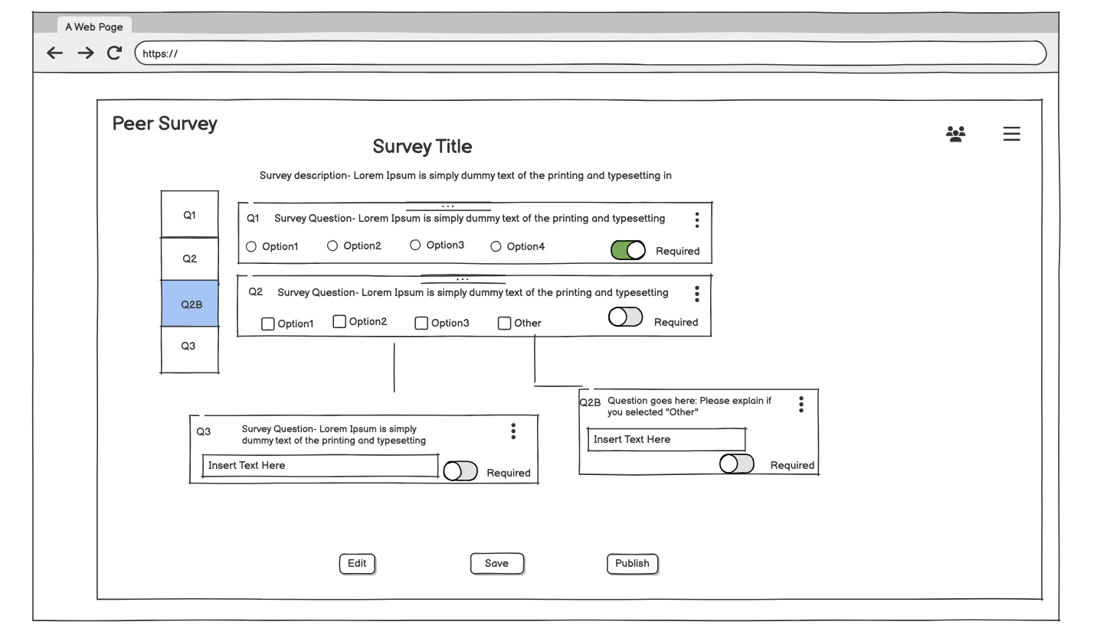

Prototype 3: <https://balsamiq.cloud/slun6c1/pji4qwg> (larger, interactive version)

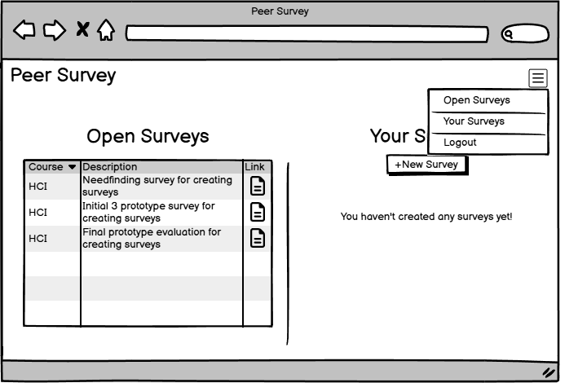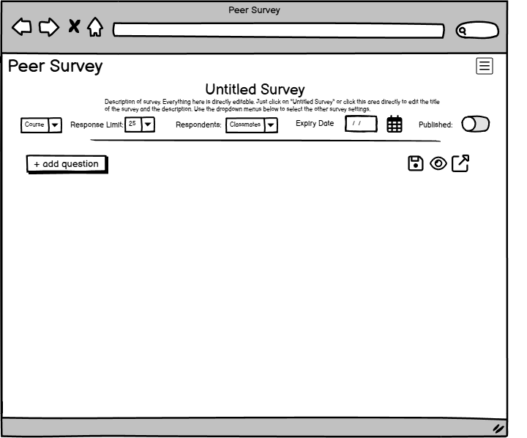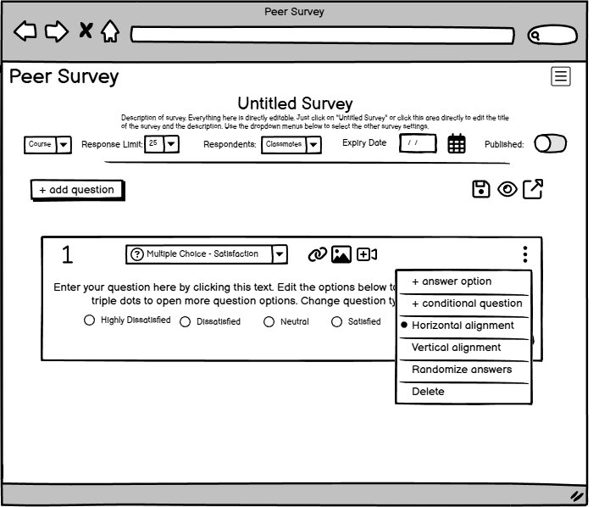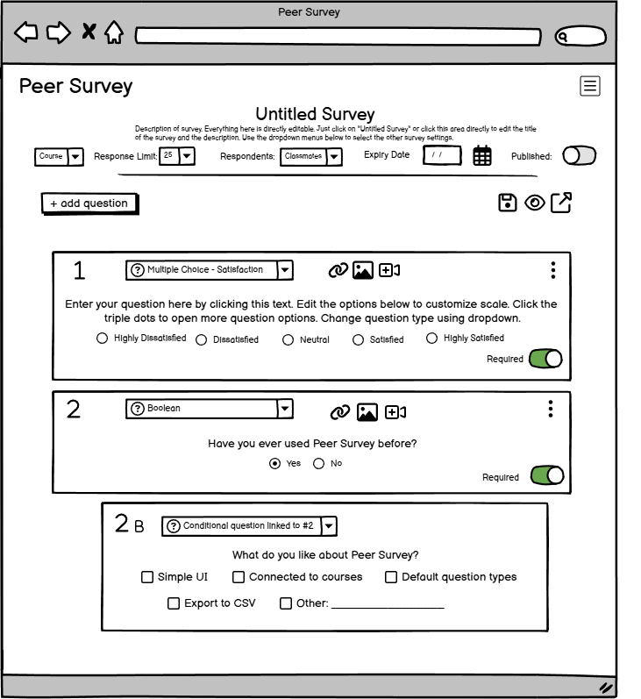

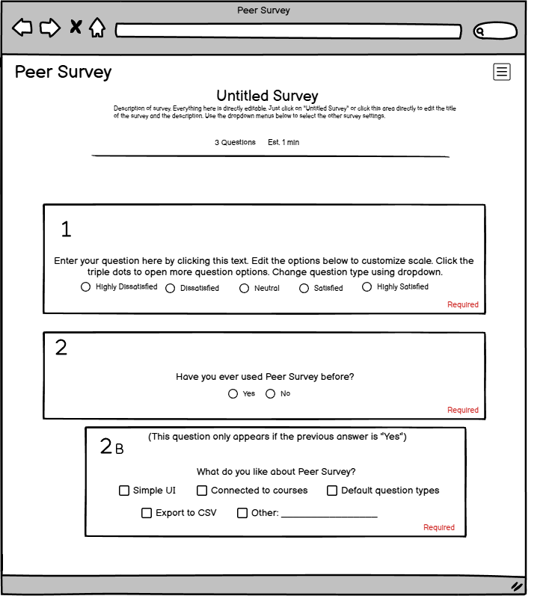

*Additional wireframe screens for Prototype 3*

## 16.5 Appendix - Evaluation Planning/Results

The first 11 questions are repeated for each prototype and on a scale of (1-strongly disagree to 5-strongly agree).

1. I know how to create a new question.*
2. I know how to change the question type.*
3. I know how to edit the question.*
4. I know how to add answer choices.*
5. I know how to customize the answer options.*
6. I know how to add external media (images, videos, links) to the questions.*
7. I know how to create a dependent, conditional question.*
8. I know how to randomize the answer options.*
9. I know how to delete the question.*
10. I know how to rearrange questions.*
11. I know how to mark a question as required.*
12. What do you like about Prototype #1?
13. What do you like about Prototype #2?
14. What do you like about Prototype #3?
15. Which prototype do you prefer?
16. Any other comments or suggestions?

See [Evaluation Results](https://docs.google.com/spreadsheets/d/1NjKPIusgfep5sYIGFmpnwVZsqnvrfJD91gg0V81J-WM/edit?usp=sharing) for the raw results.

## 16.6 Appendix - Final Prototype

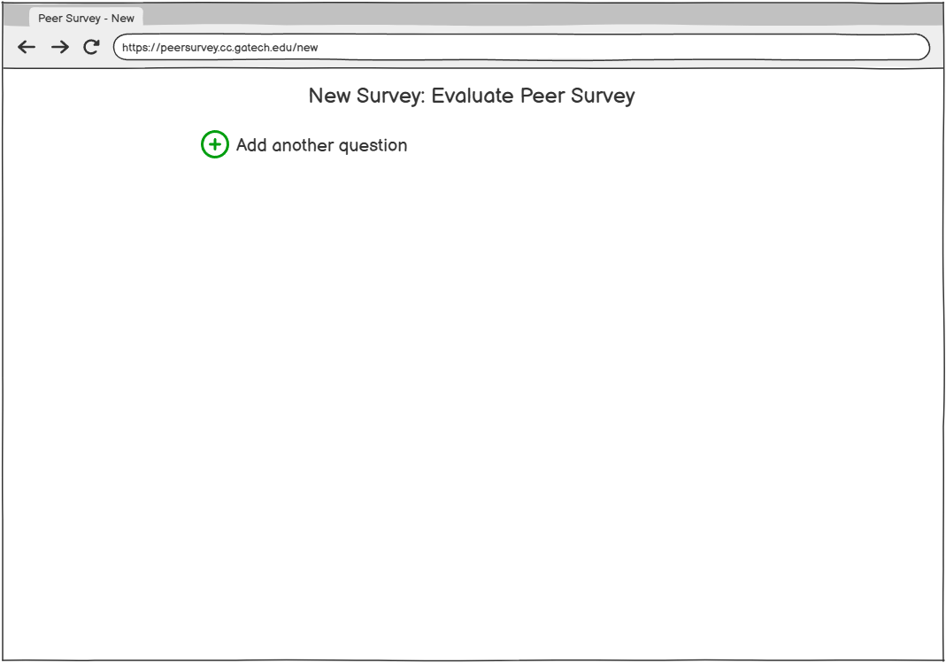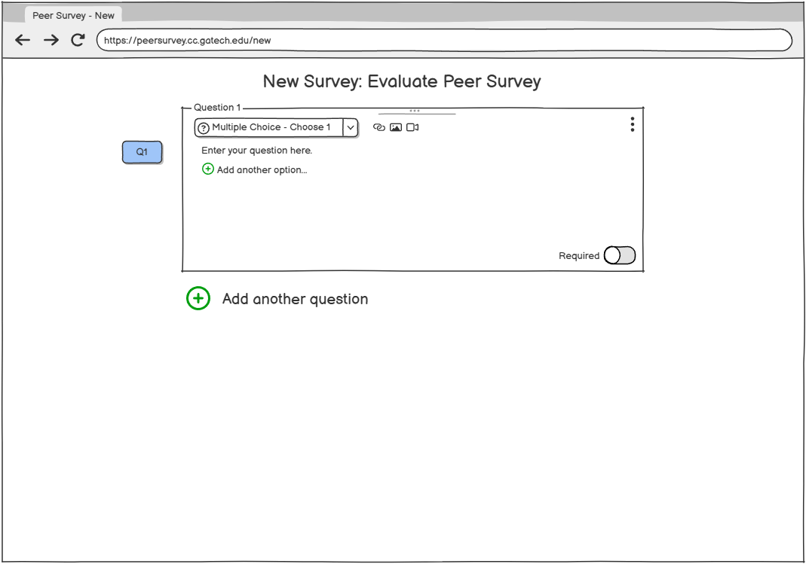

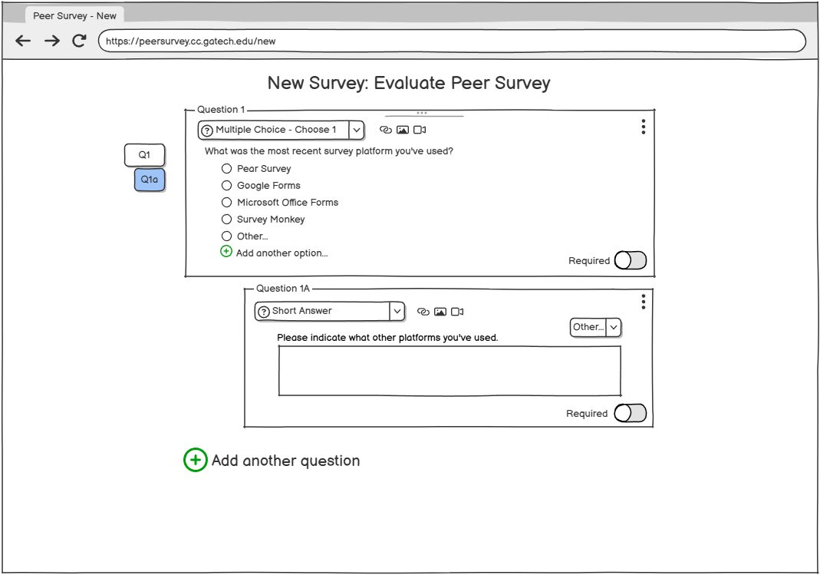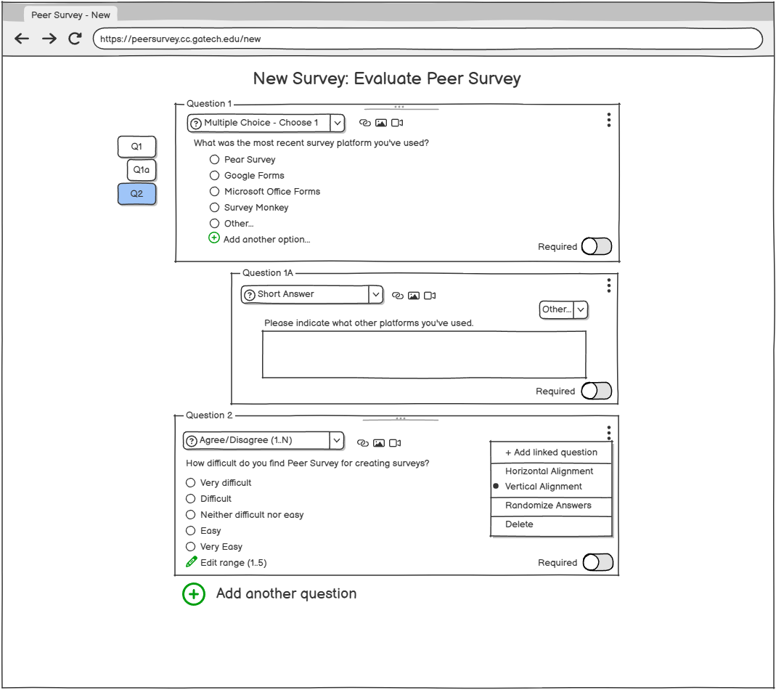

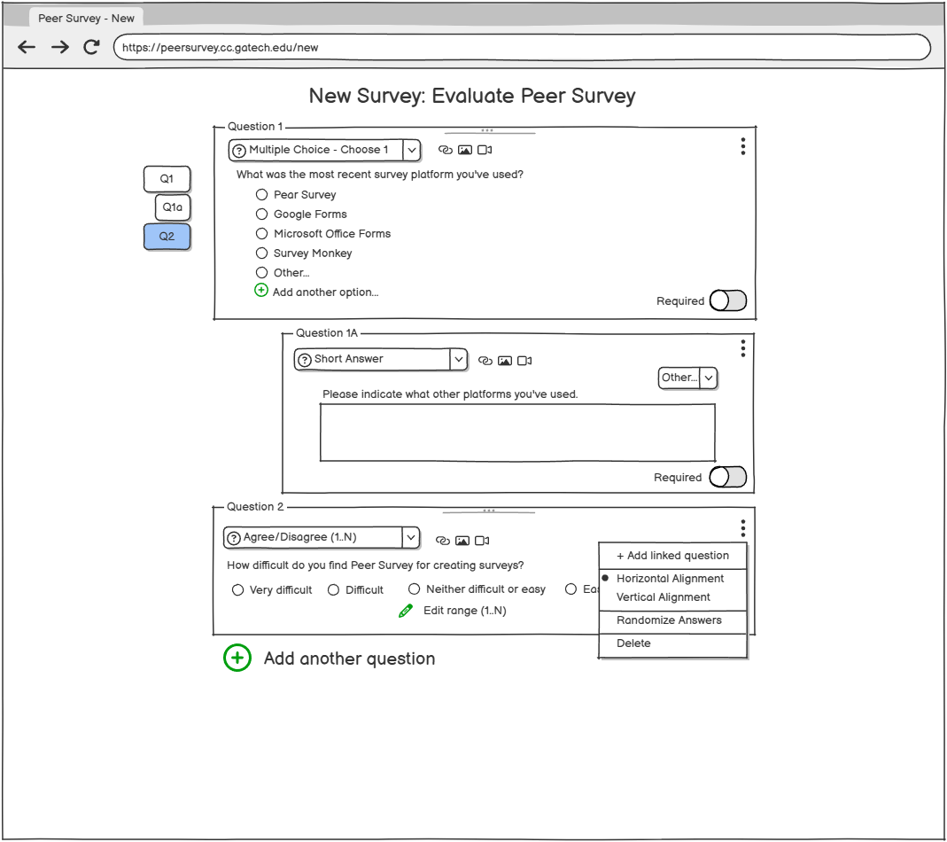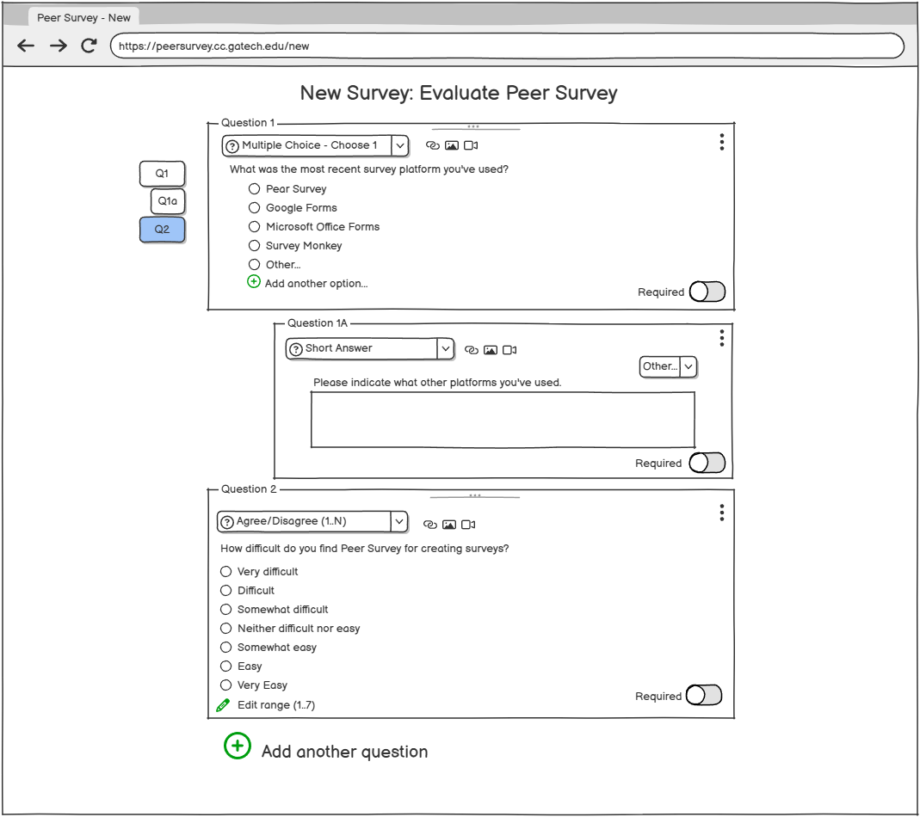

*Additional wireframe screens for the Final Prototype*

## 16.7 Appendix - Final Evaluation Planning/Results

Final Evaluation Survey

1. How easy was it to create a survey from start to finish with the final prototype?  
   (1 - Very difficult, 2 - Somewhat difficult, 3 - Neutral, 4 - Somewhat easy, 5 - Very easy)
2. How well do you think this prototype meets your needs for creating surveys?  
   (1 - Not effective, 2 - Slightly effective, 3 - Neutral, 4-Moderately effective, 5 - Very effective)
3. How do the features (such as adding questions, customization, etc.) compare between the final prototype and the current Peer Survey platform?  
   (1 - Very difficult, 2 - Somewhat difficult, 3 - Neutral, 4 - Somewhat easy, 5 - Very easy)
4. How easy is it to add question logic (like skipping questions based on answers) on the prototype compared to Peer Survey?   
   (1 - Very difficult, 2 - Somewhat difficult, 3 - Neutral, 4 - Somewhat easy, 5 - Very easy)
5. How satisfied are you with the overall design and layout of the prototype compared to Peer Survey?  
   (1 - Very dissatisfied, 2 - Dissatisfied, 3 - Neutral, 4 - Satisfied, 5 - Very satisfied)
6. How likely would you use this prototype vs Peer Survey?  
   (1-Very unlikely, 2-unlikely 3-neutral, 4-Somewhat likely, 5-Very likely)
7. (Open answer question) Which interface (the prototype or the current design) would you prefer to use for creating surveys, and why?
8. (Open answer question) Were there any parts of the prototype that you found frustrating to use?
9. (Open answer question) What improvements would make the prototype a better fit for your needs compared to Peer Survey?

**Evaluation Results**



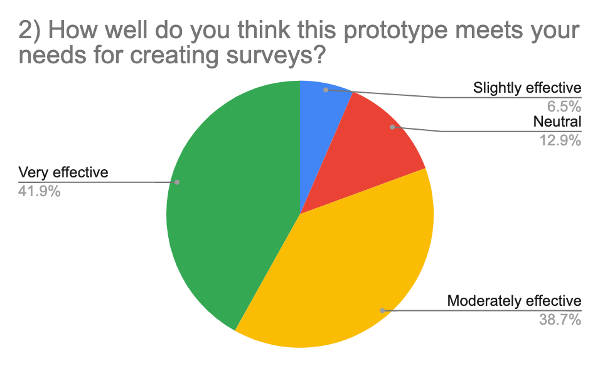

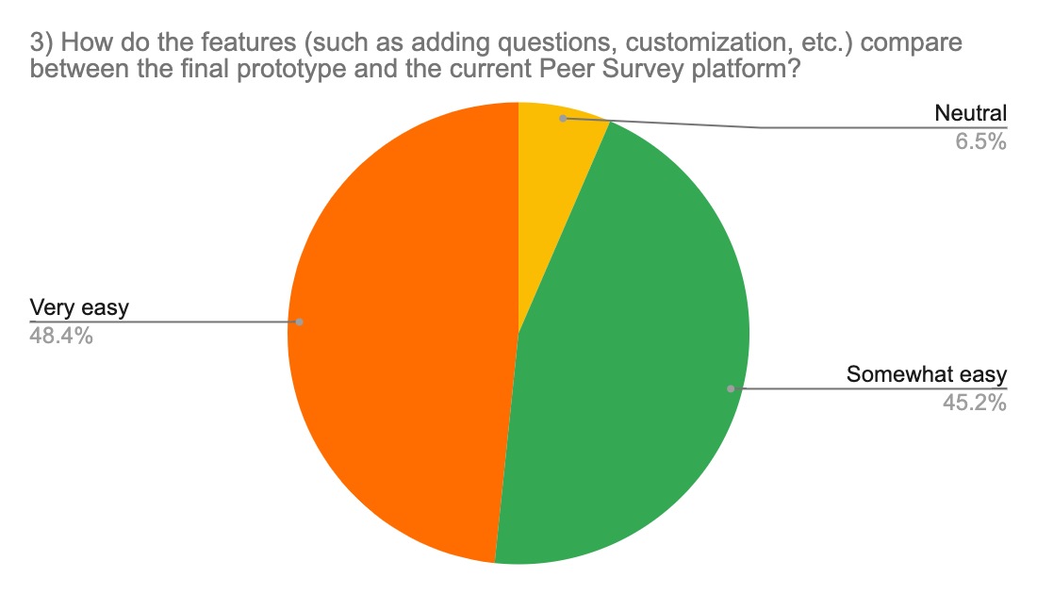

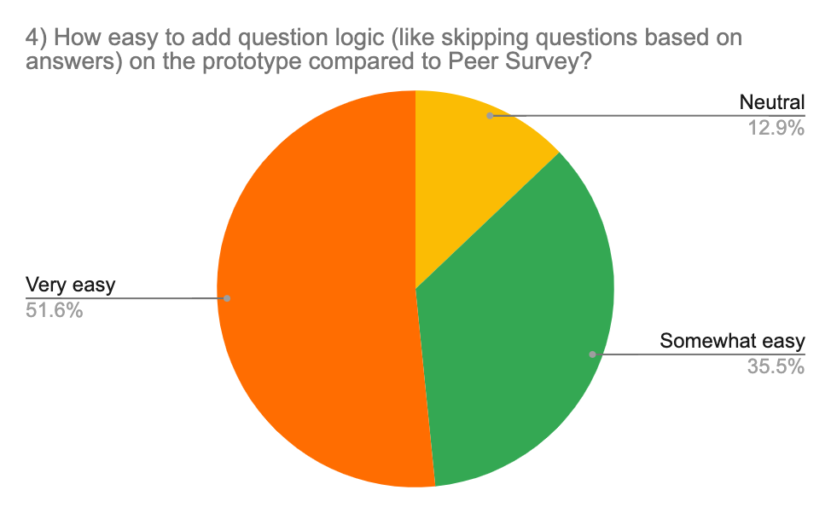



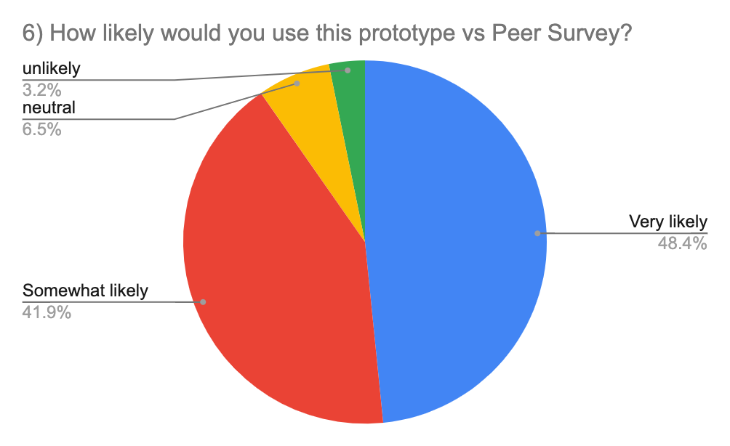

See [Peer Survey Final Prototype Survey (Responses)](https://docs.google.com/spreadsheets/d/1fVW719A8tWGJ-hjLyv6CLGMrbBGp04Xpi7SFfIqSFCQ/edit?usp=sharing) for raw results

Group Brainstorming

Top three: Question conditionals, improved question types

Numbered questions

* Have the interface display the count of questions
  + Numbered questions that can be edited to rearrange questions
* Ability to split questions into different pages w/page indicators
  + Automatically split surveys by amount of questions, or complete options page to control this
* Ability to view in single page w/page split indicators
* Tag/label questions that belong together/same section
* Have the system estimate how long a survey would take based on question count and type

Error prevention

* Highlight fields in red if not completed, can’t move forward
* More feedback before leaving the page to save your work
* Allow undo & redo

Customizability

* Allow the user to define custom Likert scales (1-5, 1-7, 0-10)
* Custom labels for likert scale questions +
  + Customizable frequency questions
* Allow multi-select/multi-choice questions to present options in randomized order
* Allow images to be multi-select/multi-choice options
* More default questions like satisfaction and importance
  + Default question types/answers are editable
  + Multichoice questions edited directly in page
* “Other” input option, opens conditional question if selected
* Allow conditional questions
* “Add question” to add it to the beginning/end of survey
* Ability to upload media into survey instead of providing published links
* Create AI feature that provides suggestions based on theme or topic of other questions

Consistency

* Survey details directly in survey edit page
* Change the name of question type like instead of “choose multiple” use multiple choice
* Dynamic text box for questions/answers

Collaboration

* Preview, share, publish survey directly in edit page
* Preview mode for surveys
* Ability to flag questions for review by collaborators

evaluation screenshots

